

Automatic Stance Detection using Sentiment analysis and LDA Topic Modelling

**Interim Report**

**DT228**

**BSc in Computer Science**

**Michael Lenghel**

**C16434974**

**Dr. John Gilligan**

School of Computer Science

Technological University, Dublin

**08/03/2020**

Abstract

This dissertation is an investigation of how a system implementing sentiment analysis and Latent Dirichlet allocation (LDA) topic modelling can create a tool which can automatically detect the stance and bias of media outlets. The stance, or slant as it is more commonly referred to, of a media outlet refers to a position that the media presents to the public in relation to a certain topic.

As an example, depending on the varying political views that certain news-reporting organisations prescribe to, the topic of Brexit has been reported on extensively with mixed reviews. Through automatically determining which news companies have a positive, neutral or negative view towards certain topics, bias can be uncovered and news sources which do not provide an objective view will be easier to disregard as untrustworthy or biased.

The range of applications of such a system is also explored. Areas of particular interest include fake news detection, how sentiment in the media towards the market correlates to stock trends, interview analysis and ethnography.

Declaration

I hereby declare that the work described in this dissertation is, except where otherwise stated, entirely my own work and has not been submitted as an exercise for a degree at this or any other university.

Signed:

_________________________

Michael Lenghel

08/12/2019

Acknowledgements

I would like to thank my project supervisor, Dr. John Gilligan for his advice and guidance throughout this project and my family for their continued support.

Table of Contents

1. Introduction 9

1.1. Project Background 9

1.2. Project Description 11

1.3. Project Aims and Objectives 14

1.4. Project Scope 16

1.5. Thesis Roadmap 16

*3 Experimental Design* 16

*4 Experimental Development* 16

*5 Testing and Evaluation* 17

*6 Conclusions and Future Work* 17

2. Literature Review 18

2.1. Introduction 18

2.2. Manual Stance Detection 18

2.3. Alternative Existing Solutions to Your Problem 20

2.4. Technologies you’ve researched 27

2.5. Other Research you’ve done 31

2.5.1. *Research of Bias in Media* 31

2.5.2. *Mapping of Imaginary Topics to real world Topics* 32

2.6. Existing Final Year Projects 34

2.7. Conclusions 35

3. Experimental Design 36

3.1 Introduction 36

3.2. Software Methodology 36

3.3. Overview of System 40

3.4. Design of User-Display 43

3.5. Design of Functionality 45

3.6. Design of Backend 47

3.7. Conclusions 47

4. Experimental Development 49

4.1. Introduction 49

4.2. Technical Architecture Summary 49

4.3. User-Display 50

4.3.1 *Media Outlets’ Sentiment Representation* 50

4.3.2 *Representation of Imaginary Topics* 53

4.4. Functionality 55

4.4.1 *Data Sourcing* 55

4.4.2 *Data Cleaning and Building the LDA Topic Model* 58

Data Cleaning and Building LDA Model Process 58

4.4.3 *Mapping Imaginary Topics to Real World Topics* 59

4.4.4 *Mapping Topic Words to Original Sentences* 60

4.4.5 *Drawing more Information from the Results and Improving Graph Representation* 61

4.4.*6 Improving the Quality of Topics* 61

4.4.*7 Overview of Key Code* 62

4.5. Backend 62

5. Testing and Evaluation 63

5.1. Introduction 63

5.2. System Testing 63

5.2.1 *Unit Tests* 64

5.2.2 *Integration tests* 65

5.2.3 *System testing* 66

5.2.4 *Acceptance Testing* 66

5.2.5 Grey-Box Testing 67

5.3. System Evaluation 68

5.3.*1 User Ability to Guess Topics* 68

5.3.*2 Effect of User Bias when understanding Topics and Sentiment* 70

5.3.*3 Improvements on Perplexity and Coherence Scores* 70

5.3.*4 Sentiment Evaluation* 71

5.3.*5 Automatic Stance Detection Scoring Analysis and Baseline* 72

5.4. Conclusions 73

6. Issues and Future Work 73

6.1. Introduction 74

6.2. Issues and Risks 74

6.3. Plans and Future Work 76

6.3.1. GANTT Chart 77

First GANTT Chart 77

Second GANTT Chart 77

*[Kanban List to show how work was worked on iteratively and how tasks were handled]* 78

Bibliography 79

Appendix 83

Appendix A 83

Screape_articles.py: 83

generate_lda.py: 86

Visualising_lda.py 94

Format.py 100

test_visualise_lda.py 102

test_scrape_articles.py 103

Table of Figures

Figure 1 Stage of Developing Sentiment Analysis Algorithm [7] 12

Figure 2 Machine learning classifier model [45] 13

Figure 3 LDA Topic Modelling Through Mapping Words to Topics [6] 14

Figure 4 Types of Qualitative Content Analysis [26] 19

Figure 5 Thematic Analysis Process [29] 19

Figure 6 Sentiment Analysis Graph Hops [11] 21

Figure 7 Calculating Subjectivity Score for Topics [11] 21

Figure 8 Sentiment Analysis Positive and negative Distribution [46] 22

Figure 9 Differences In Sentiment Library Accuracy [48] 22

Figure 10 Thirdhand Smoking News Topic Model [5] 24

Figure 11 Topic to key word link [5] 24

Figure 12 Publisher Bias Detection [13] 25

Figure 13 System Architecture for Bias Detection [16] 26

Figure 14 Manual Labelling [17] 27

Figure 15 Sci-learn Machine Learning Applications [21] 29

Figure 16 Gensim Classifier with food words (blue), sports words (red) and weather words (green) [22] 29

Figure 17 WORDSEER Visualisation of Text 30

Figure 18 Bias within Media [13] 32

Figure 19 Summarization Topic Labelling [50] 33

Figure 20 Spiral Model [32] 36

Figure 21 Feature-driven development model [36] 37

Figure 22 Extreme Programming Model [30] 38

Figure 23 Kanban Progress Chart 38

Figure 24 Kanban Example [31] 39

Figure 25 CRISP-DM [43] 39

Figure 26 System Design 41

Figure 27 System Sequence of Operation Diagram 42

Figure 28 Example Grafana Dashboard [55] 43

Figure 29 Word Frequency Topic Distribution Histogram 44

Figure 30 Hand drawn Topic Display 44

Figure 31 User use case diagram for viewing topics and sentiment in media 45

Figure 32 Process for Data Cleaning for Sentiment Analysis and LDA Topic Modelling 46

Figure 33 Author's Dissertation Kanban 47

Figure 34 System Design 49

Figure 35 The Independent Average Objectivity 51

Figure 36 Daily Mail Average Objectivity 51

Figure 37 Daily Mail Average Sentiment 51

Figure 38 The Independent Average Sentiment 52

Figure 39 Daily Mail Modified Mode Sentiment 52

Figure 40 The Independent Modified Mode Sentiment 52

Figure 41 Topic Modelling Visualisation for Topic 42 (Hospitals) 53

Figure 42 Topic Modelling Visualisation for Topic 26 (Politics) 54

Figure 43 Topic Modelling Visualisation for Topic 41 (Generic Words) 54

Figure 44 Web Scraper Architecture for URLs 56

Figure 45 Web Scraper Architecture for Links 57

Figure 46 Text Mining and Building LDA Model 58

Figure 47 Choosing Optimal Number of Topics [56] 59

Figure 48 Topic Word Dictionary Mapping 60

Figure 49 Topic Word Dictionary Mapping 61

Figure 50 MySQL Sentiment Table 63

Figure 51 Unit Tests Execution 64

Figure 52 Unit Tests Code 65

Figure 53 Integration Testing Code 66

Figure 54 Stages of Integration Testing [41] 66

Figure 55 White-Box Testing [39] Figure 56 Black-Box Testing [39] 67

Figure 57 Grey-Box Testing [39] 67

Figure 58 LDA Survey used to Evaluate Model 69

Figure 59 Sentiment User Survey 72

Figure 60 Independent Mode Sentiment 73

Figure 61 Independent Average Sentiment 73

Figure 62 GANTT Chart 77

Figure 63 GANTT Chart 2 77

Figure 64 Dissertation Kanban Report 78

# 1. Introduction

This project is an implementation and analysis of automatic stance detection, an approach which has been defined as automatically classifying the attitude expressed in a text, or body of texts, towards a target such as Hillary Clinton to be “positive”, “negative” or “neutral” [57]. In this project the scope of automatic stance detection will be to determine the views or position that the media takes in regards to various topics.

This introductory chapter will look at introducing automatic stance detection as well as the components which facilitate stance detection - namely natural language processing techniques, sentiment analysis, LDA topic modelling, mapping imaginary topic names to their real life counter parts, and how this thesis plans to unite them in order to be able to determine how a newspaper company reflects a specific stance towards certain topics and finally the necessity of a stance detection algorithm to determine bias and inform the public which news companies are credible or untrustworthy.

## Project Background

#### 1.1.1. Automatic Stance Detection

This projects core functionality is automatic stance detection which is an approach which will use sentiment analysis and topic modelling in order to understand the position of media in regards to multiple topics.

Topic models identify latent patterns of word occurrence using the distribution of words in a collection of documents [61]. LDA topic modelling will encapsulate the automatic creation of topics through correlating the phrases or words within a body of texts that relate to a specific set of topics. Traditionally, when using an LDA topic model, the researcher interprets and labels the topic manually as discussed within *Reading Tea Leaves: How Humans Interpret Topic Models* [62]. This project will implement a novel approach that will attempt to accurately label topics automatically.

Opinion mining and sentiment analysis, deals with the computational treatment of opinion, sentiment and subjectivity in text [63] and will be the driving force behind automatically decrypting the sentiment and ultimately the opinion score within each sentence that relates to a respective topic.

Both approaches described above will use machine learning in order to build models that can create topics (through aggregating the words that fall into a topic) and understand their sentiments. An average is then accumulated for each sentence that is linked to its respective topic in order to discover the overall stance towards that topic. The LDA topic model creates imaginary topics, which symbolises that while the words link to a logical topic, the topic name itself is not labelled by the LDA topic model due to the complexity of accurately defining a category to represent the topic.

An example of the operation of automatic stance detection within this project is finding all of the sentences within articles that discussed Brexit and determining the sentiment score on each occurrence through the use of subjectivity and polarity scores. Subjectivity will be ranked with a score between “0” and “1” where “0” is very objective and “1” is very subjective and this will test how neutral news companies are when discussing various topics. Polarity (a score between negative one and positive one will test whether the statements are positive or negative towards the topics in question, where “negative one” is a strongly negative sentiment and “positive one” is a strongly positive sentiment. Based on the objectivity and strength of the sentiment scores it becomes straightforward to dictate whether or not specific news companies are biased towards topics such as religion, Brexit, political leaders or any other topic that is discussed at length within articles.

Latent Dirichlet allocation (LDA) topic modelling developed by Blei in 2003 [6] has grown to be known as one of the most used topic modelling algorithms. LDA is essentially a generative probabilistic approach to build topics from multiple documents using word frequency. Its use within natural language processing has increased significantly in the last number of years and it is also a major area of research within computer science.

LDA is predominately used by organisations to analyse qualitative data such as interviews and surveys automatically by building topics in conjunction with thematic analysis. Using LDA to build topics in various media platforms such as twitter and newspapers is a more recent trend and an immense point of discussion within computer science currently.

As discussed earlier, this project will also look to implement a novel approach that will label the topics. Many approaches that attempt to label LDA topic models have been implemented including *Understanding LDA in Source Code Analysis* [58] which offers the approach of using the most dominant topic words to label the topics, but this approach has been shown to not always clearly represent the topic by David M. Blei within the peer-reviewed article Probabilistic Topic Models. [59] Multiple supervised and unsupervised approaches have also been implemented such as *Automatic Labelling of Topic Models [60]* which have attempted to use external data sources to label topics based on probabilistic searches. These attempts returned more correlative results then simply using the most dominant topic names, but heavily rely on the topics being well defined and distinct.

#### 1.1.2. Value of Stance Detection

According to the Joint National Readership Survey (JNRS) 2012/2013 almost three million people in Ireland read the newspaper regularly [1]. The views presented by the media can undoubtedly influence and skew public opinion. The manner in which various issues such as mental health, political movements and technologies are presented is crucial in understanding the position that a news company is attempting to uphold in regard to that topic and this can become an issue where a newspaper company is biased towards certain topics. As a simple example, by simply describing a particular product or technology in a negative or positive light it can drastically affect the products public perception on a mass scale and naturally as a direct result increase or decrease the sales associated with this product.

A need for automatic media stance and bias detection is also evident through the large amount of research work residing within this area. Multiple dissertations, research papers and conferences have been dedicated to unlocking more powerful methods to process media information and extract more meaningful data.

Since the conception of sentiment analysis, the area has undergone a large shift of alterations. The cornerstone of this area where the level of research rose significantly was in 2004 where there was an outbreak of subjective text on the web. Consequently, 99% of the papers on sentiment analysis have been published after 2004 [2]. Since then the area has evolved significantly, as have the terms dictating this area. Originally sentiment analysis within the media was referred to as “Sentiment Analysis”, which then shifted to “Points of View Analysis” and now finally in 2019 it is referred to as “Stance Detection” or “Slant Detection”.

There have been multiple methods developed in order to further improve the accuracy of slant detection and understand the underlying sentiments behind text. These methods range from manually tagging words sentences with their intent as implemented with *Recognizing Contextual Polarity in Phrase-Level Sentiment Analysis* [64], to rule based systems such as the implementation within *Lexicon-enhanced sentiment analysis framework using rule-based classification scheme* [65] as well as supervised and unsupervised machine learning models through neural networks and deep learning which has been implemented within the research of the paper titled *Twitter Sentiment Analysis with Deep Convolutional Neural Networks* published in late 2015 [66]. This area is still evolving with many problems still without optimal solutions such as understanding sarcasm as well as grammatically incorrect language.

The key components within this thesis that separates it from other projects is the combination of both sentiment analysis and LDA topic modelling, as well as the labelling of topics through the mapping of imaginary topics to real topics. Through mixing sentiment analysis and LDA, a number of issues are encountered such as the retrieval of sentences from word dictionaries. Many solutions exist to this issue, primarily through the use of word vectors, guided machine learning models, finding and the hypernym of the most weighted words in the topic but all solutions to date have large underlying issues and often are unreliable. The approach that is taken to solve this issue will be a large area of complexity.

## Project Description

Automatic Stance Detection using Sentiment analysis and LDA topic modelling is a project that will investigate how popular news-reporting organisations in Ireland and abroad portray information to the public. The main application will be to identify what stances the overall media and different newspaper companies across different countries take on different issues and to assist in determining bias. *The paper Joint Sentiment/Topic Model for Sentiment Analysis* [67] defines stance detection as the act of detecting sentiments and topics simultaneously.

Broadly, stance detection portrays the views held by the media to specific topics. Sentiment analysis is key in order to understand the objectivity and sentiment within each sentence of the news, while LDA topic modelling is responsible for mapping the sentences to their appropriate topic. Sentiment analysis works by first applying natural language techniques in order to clean sentences of information that are useless for analysis. A host of techniques such as creating bigrams, lemmatizing words, removing stop words that do not carry any weight when it comes to measuring sentiment such as “to” and “or” and many more. The quality of data cleaning greatly effects the accuracy of the sentiment model results and the more thoroughly techniques are applied, the greater the accuracy when calculating the sentiment scores for thousands of sentences.

The data cleaning performed to be able to determine the sentiment of a sentence is as follows.

* Tokenization where each text is broken up into individual words.
* Stop word filtering where all stop words which are essentially words that carry no sentiment such as “to, is and I” are removed from the text.
* Useless information such as emails and numerical values such as dates are removed.
* Stemming and lemmatization is performed where suffixes and prefixes are removed to transform the word into its base state, for example the word “going” is transformed to the word “go”.
* A classification algorithm which determines the class a sentence belongs to, either positive, neutral or negative.
* Appling the sentiment class to the proposed sentence.

Figure 1 Stage of Developing Sentiment Analysis Algorithm [7]

Once data cleaning is performed different systems have been developed to classify the sentiment of a piece of text. Rule-based approaches use human-crafted rules to help identify subjectivity and polarity where a subjectivity score is how a subjective a sentence is and the polarity is whether or not a sentence was positive, negative or neutral. A basic example of a human-crafted rule is where there are two lists of positive and negative words and for each word in the sentence the words are counted. The score is then calculated based on how many bad words versus good words were counted within that sentence.

An automatic approach uses machine learning techniques. Within this technique sentiment analysis is modelled as a classification problem, where a classifier is input text and returns a category such as “positive”, “negative”, or “neutral”. More sophisticated sentiment analysis classifiers return a score between two integers which allow further granularity in order to understand the differences between “very positive or very negative” and “slightly positive or slightly negative”.

The models learn to associate a particular input with a particular sentiment score based on the sample data that is provided for training the model. The text input is converted to a feature vector that the model can interpret and the larger the data set, the more accurate the model can become. Naïve Bayes or neural networks are example of classification algorithms that can be used to understand the text.

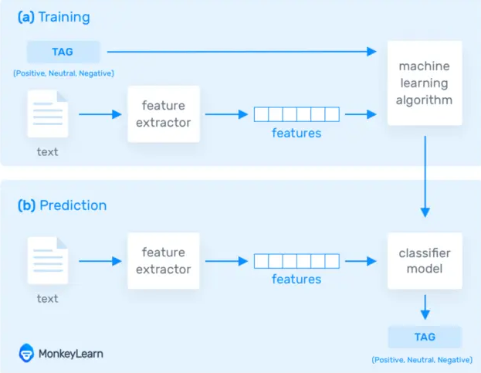

Figure 2 Machine learning classifier model [45]

Grouping sentences to certain topics is handled by LDA topic modelling which is a growing area within natural language processing and machine learning. Topic modelling can be used to discover the abstract topics that occur in a collection or group of documents through examining the themes in a large collection of documents. A more formal definition of topics is that a topic is a multinomial distribution over a fixed vocabulary [3].

I will be using topic modelling to build topics within newspapers articles. The topic modelling algorithm of choice that I will be using is LDA which is a probabilistic method. LDA maps all of the words within documents to topics in order to match them to imaginary topics. A more formal definition of LDA is “LDA is a generative statistical model that allows certain sets of observations to be explained by unobserved groups that may explain why some parts of the data are similar.” [4].

The true power of LDA is that it can build a model that correlates certain words with a topic which can save a great deal of time as ordinary thematic analysis would require analysing texts by hand and manually mapping certain words which link to a topic. A basic example is that if in an interview a key topic that a company is interested in is streaming services, then the words correlated with streaming services could be “HBO, Netflix and Amazon prime” and all other streaming services deemed important. This process would then need to be applied to every topic which can be cumbersome where the topic count can be within the hundreds.

The approach that I am taking is to build a reference model to multiple topics such as religion, sports and politics, be able to expose when a news source is referencing a particular topic and then calculate their stance on this topic through a sentiment score where they discussed a particular topic across multiple papers. Afterwards, different newspapers such as “The Independent” and “The Daily Mail” can be compared on how they discuss this topic to determine if one holds a stronger stance on certain issues, favours certain political parties over others or even upholds a bias, be it negative or positive. Naturally this stance will be also be calculated over an aggregation of multiple media outlets and therefore will be able to pinpoint how the media as a whole within the selected news companies perceive certain topics.

An example of a recent research project done within the scope of LDA is the journal publication [5] “Data Analysis and Visualization of Newspaper Articles on Thirdhand Smoke: A Topic Modelling Approach”. Within this research a topic model is built on whenever third hand smoke is mentioned within the Chinese Media. This model was then used to understand the role the media plays in communicating this health concern.

The below diagram shows how LDA topic modelling generates topics. Firstly, it chooses a distribution of the topics which is displayed through the histogram on the right and then for each word choose a topic assignment (which is represented as the coloured coins) and then choose the words corresponding to each topic.

Figure 3 LDA Topic Modelling Through Mapping Words to Topics [6]

## Project Aims and Objectives

The overall aim of this dissertation will lead to the creation of a system that can successfully determine the overall sentiment and objectivity of news companies to various topics in order to discover stance, as well as bias where it is present.

Firstly, a suitable data source of news articles will be required to train models. For this phase, testing found there is a requirement of at least seven thousand articles in order to be build a working model. Once a working model is built the next phase will be to connect to external API’s that provide newspapers and web scrape articles of news companies that do not explicitly provide API’s.

The next phase requires the cleaning of data for both the LDA model and the Sentiment Analysis model. This will require tokenization, removing stop-words, getting rid of useless information such as numerical values, emails, headers, dates, new line characters and other information which is not useful for either building a model or sentiment analysis.

The next step is to build a suitable LDA model that can select themes from the articles and link the words of those themes to those models. There are a wide range of methods to implement this feature and many different libraries that can both optimise this model as well as improve the quality of models created.

Following the creation of an LDA model, a problem that occurs is that words are linked to an arbitrary number and an algorithm mapping the number to a topic will be required. This algorithm requires mapping word frequency within each topic number and using probabilistic similarity methods to match the number to the real topic. The data size will be important as there is a requirement of many articles to map this number correctly.

While all of the data cleaning for the sentiment model will be performed and fine-tuned within this project, the classification of the sentiment model will be built using external libraries. In tests it was found that the classification model for sentiment analysis is difficult to fine tune accurately due to the large amount of edge cases that cause many misinterpretations such as sarcasm, grammar and spelling mistakes. In order to increase the accuracy of the LDA topic model and mapping of the imaginary to real name topics, less focus will be placed on the classification modelling algorithm for sentiment analysis and a well-rounded, accurate sentiment analysis model will be used.

A method of visualization of the LDA topics will be another key objective in order to be able to accurately determine how accurately words map to their respective topics, as well as how strongly linked certain topics are to each other.

An algorithm to retrieve the original sentences will be needed in order to apply sentiment analysis on each sentence within a topic. LDA topic modelling only links words to a topic, but retrieving the sentences is crucial in order to understand context and accurately measure the sentiment presented towards topics.

The sentiment score will need to be mapped to the created topic inside the LDA model which may prove to be a challenge as a great deal of processing separates the two methods and some ingenuity to map them together may be required.

Another key objective will be to evaluate the quality of the topics created through the LDA model, as well as how accurate the sentiment analysis scores were for each topic by comparing their accuracy in understandings topics to the accuracy of random participates. These participates will be required to fill out a questionnaire where they try to map the given words to a topic that the LDA algorithm created and see if they arrived at the same conclusion as the model.

Finally, the last objective is to further increase the accuracy of the models through better data cleaning, reducing the number of edge cases where the algorithm loses accuracy, increase the data size so that the model can be trained more accurately, creating the optimal number of topics and many more techniques that are commonly used in natural language processing and machine learning in order to further improve the accuracy of both the LDA topic model and sentiment analysis scores.

## Project Scope

This system will not be able to make direct assertions about news-reporting organisations. The implementation will instead create scores that provide a probabilistic approach with some degree of error to dictate how positively or negatively the media and specific news outlets depict certain topics and it is then up to the user of the system to make a more profound judgement on the implication of the results. A negative score does not necessarily imply that the media is against this topic as it may indicate that they talked about it negatively in the past and that they do not hold the same position.

There are no plans to create this system on a remote server that will be hosted within a web application. Everything within this system will be ran locally on a machine that sets up the environment using the documentation that is provided. The results will be displayed through a Grafana interface in order to be understood more clearly. The key results are the objectivity of a news outlet in relation to various topics, as well as their polarity.

The implementation of the system will be targeted towards the English language. The system will not look towards extensibility for multiple languages.

## Thesis Roadmap

This section will provide a summary of each of the chapters covered within this report.

2 Literature Review

This chapter explores the background research related to LDA topic modelling, sentiment analysis, the visualization of the models, finding a data source to train the models and connecting to API’s which source real newspaper articles. This chapter will also discuss the array of other relevant research that has been performed within this area of natural language processing and machine learning.

### 3 Experimental Design

The design chapter delves into and breaks down the different software methodologies that were considered and the thought process that was used to arrive to a conclusion. A view of the system architecture, use-cases and sequence operation will then be presented.

### 4 Experimental Development

The development chapter describes the entire development process of the system using the technical architecture that was described within the design section. The challenges and issues encountered will also be broken down within this chapter providing both the solutions and trade-offs.

### 5 Testing and Evaluation

This chapter will describe how the system was tested and evaluated. The key components that will be tested will be the accuracy of the LDA model to create topics, as well as the accuracy of the sentiment analysis. Both components will undergo multiple forms of testing and evaluation that will compromise both computer-only generated scores and how well the machine learning can resemble a real individual’s ability to manually understand topics and sentiment.

### 6 Conclusions and Future Work

The final chapter will reflect on the entirety of the project and will discuss the conclusions drawn and future work planned for the project.

# 2. Literature Review

## 2.1. Introduction

In this chapter the key areas of research that are related to automatic stance detection will be presented. To reiterate, automatic stance detection is an approach which will use sentiment analysis and topic modelling in order to understand the position of media in regards to multiple topics. This includes the exploration of modern implementations and limitations of sentiment analysis, LDA topic modelling and the complementary techniques and components that will be used to create and evolve the models such as natural language processing techniques, and external methods to improve accuracy.

Linking back to the first chapter, the projects aims and objectives that were defined will be further examined and updated in order to monitor the evolution of this project’s architecture as new improved approaches and limitations are identified.

The literature review will also examine areas that are closely related to stance and bias detection. Stance detection has many applications that are extremely significant and applicable within the modern world of business and research sciences. Applications range from bias and fake news detection to monitoring the effects that media sentiment has on consumer confidence within the market and consequently the stock market. Accurate stance detection systems are currently in demand in a large number of corporations and it would be remiss to not examine closely related applications in order to form a better understanding of the evolution and application of this project.

## 2.2. Manual Stance Detection

The manual analysis of stance within a body of text is a cumbersome and tedious process that is difficult to apply at scale. Manual stance detection relies on iterating through qualitative data, also known as categorical data, with the aim of finding the position of the author to the topic. The area of research with a suite of techniques to analyse this type of information is known as qualitative research which is defined as empirical research where the data is not in the form of numbers. [25]

A great deal of research has been performed within the area of qualitative research in order to facilitate a better understanding of how to standardise the extrapolation of meaning from texts. Different techniques are outlined below and discussed in order to determine the best method for manually identifying stance within newspaper articles.

The diagram below illustrates the different types of qualitative content analysis methods and the complementary algorithms that are directly linked. Summative uses keywords, conventional uses categories developed during analysis and directed is developed from categories created before the analysis. [26]

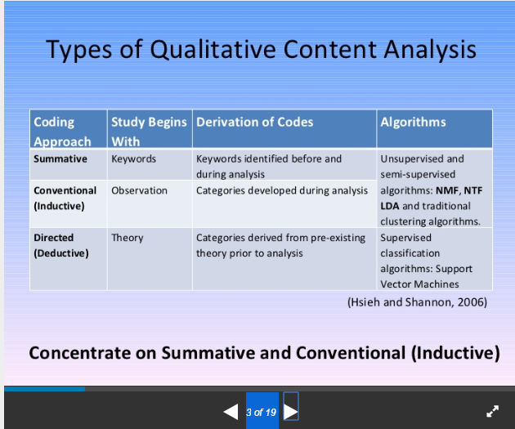

Figure 4 Types of Qualitative Content Analysis [26]

The method of qualitative data that seemed to apply the most to the area of manually creating topics through analysing word frequency patterns was thematic analysis. Thematic analysis is a method of content analysis which contrasts with other qualitative analytic approaches such as discourse analysis and grounded theory which are generally considered to be methodologies more so then methods. Thematic analysis emphasizes identifying, analysing and interpreting patterns of meaning (or "themes") within qualitative data. [27]

The basic key summary of the thematic method is as follows. Thematic analysis is implemented through the process of creating codes or words which will match to a theme. The codes are then later organised into themes. [28] An illustrative example is where the theme is “Phone Brands” and the codes are Nokia, Samsung and iPhone.

Thematic analysis provides the ideal manual representation of creating the LDA topic model. The disadvantages of thematic analysis are evident, when compared to the automatic approach discussed within this dissertation.

The machine learning model is capable of automating the creation of these codes and themes and then identifying them within thousands of articles in less than half an hour, while an analyst could spend hours iterating over just a handful of articles in order to assign codes to themes, and then find them all individually.

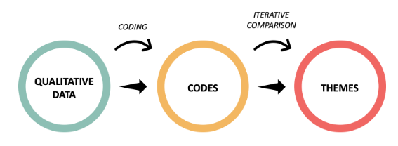

Figure 5 Thematic Analysis Process [29]

Once all of the occurrences of the codes and themes are found, the next phase of manual stance detection is opinion mining. Performing opinion mining manually is less intensive then thematic analysis as there is less setup, but it is still impractical at scale. Calculating the sentiment from tens of thousands of sentences is trivial for a machine learning sentiment model, but for an individual, can take weeks of tedious, unrewarding work.

LDA topic modelling is essentially an altered automatic thematic analysis which can dynamically create these themes and match them to the words based on the patterns within word frequency. By being able to automatically create these topics the quality of the topics can be assured as a machine can consider many more articles than an individual could have read. The topics are also created based on frequency and as a result a machine algorithm is more likely to create the most relevant topics.

## 2.3. Alternative Existing Solutions to Your Problem

The two main components of automatic stance detection are sentiment analysis and particularly topic modelling which are both currently a growing area of interest within computer science and there are a large range of projects within both fields. Multiple projects have been built around the area of detecting media bias, detecting points of view, fake news detection, stance detection and topic authenticity. The purpose of this section is to explore and discuss the various research projects related to these topics that share similarity to the solution presented within this dissertation and draw conclusions around their application, significance and learning points.

*2.3.1. What is Automatic Stance Detection?*

Automatic Stance Detection is an approach which uses sentiment analysis and topic modelling in order to understand the position of media in regards to various topics. The automatic generation of topics is controlled by the topic modelling algorithm of choice which dynamically creates topics and binds the words most likely to be associated with that topic to their respective topics. The sentiment analysis is performed through the application of a sentiment classifier on each occurrence of each topic through their respective sentences. A sentiment score is averaged and whether this score is positive or negative dictates the stance of the news company towards those topics. The word stance in this context is the aggregation of sentiment in each mention of a topic and this is why the two algorithms are integral to the function of automatic stance detection.

Both sentiment analysis and topic modelling require the use of machine learning in order to automatically process the data at a large scale. Sentiment analysis is integral in order to automatically understand the intent behind sentences, but grouping what the sentences are discussing to their correct category is the job of the topic model. The topic modelling algorithm of choice that is utilized within this thesis will be Latent Dirichlet allocation topic modelling which is a popular approach within machine learning to identify topics within documents. A popular definition of LDA is as follows, “Each document can be described by a distribution of topics and each topic can be described by a distribution of words” [8].

As a basic example, if a media company receives a polarity score of “0.9” towards a topic such as a political party, this means that it is very likely that the news company desires to represent this political party in a positive light and biased towards this party. On the other hand, if a score of “0.1” is generated this means that the news company is biased and against this party. The scores are calculated through a number of different means. The sentiment analysis model is applied on each sentence and all sentences that are grouped under discussing this political party are averaged against each other in order to find how this party is generally presented within various media outlets.

A neutral base line will also be developed. Naturally, a score of 0.6 does not necessarily imply that a news company is biased as there are many factors within language that can slightly skew the score that is output. This base line has the potential to extend further and appropriate research will need to be dedicated in understanding this base line.

#### 2.3.2. Topic Modelling and Sentiment Analysis within news media

A conference paper with the title “Large-Scale Sentiment Analysis for News and Blogs” [11] is a project that shares a great deal of similarities with this dissertation. This paper investigates the creation of binary sentiment scores, either positive or negative, in order to dictate how each mention of a topic in a corpus is presented.

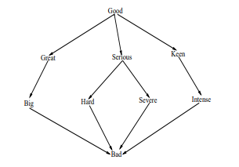

Figure 6 Sentiment Analysis Graph Hops [11]

An interesting conclusion drawn from the above conference paper is taking into account subjectivity scores. The amount of subjectivity associated with each entity or topic is calculated through reading all news texts over a period of time and counting the sentiment in each occurrence in order to get the average subjectivity for that topic. This subjectivity can be evaluated through the follow calculation and acts as the base line for calculating sentiment scores where the topic is mentioned.



Figure 7 Calculating Subjectivity Score for Topics [11]

Sentiment analysis has been used in many different research projects to achieve a wide range of different goals. In an article “Capturing Favourability Using Natural Language Processing” [46] published in 2003, studies were performed in order to understand how automatic sentiment analysis using natural language processing compares to that of a human’s ability to understand sentiment. Humans were asked to manually review different products brands as either favourable or unfavourable and the system used reviews from the products website. While no affirmative conclusion was confirmed, the ratio displayed that on average their sentiment analysis algorithm was correct only 75% of the time.

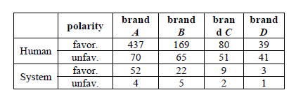

Figure 8 Sentiment Analysis Positive and negative Distribution [46]

However, since 2003 sentiment analysis has undergone a large number of shifts and ultimately, improvements. Not only are models significantly more accurate, but the range of results from a sentence expand past binary (positive, negative) results. Using word vectors and multiple new optimisations made within the field, sentiment analysis algorithms have been found to be able to distinguish between very positive, slightly positive, neutral, slightly negative and very negative and the best sentiment analysis models (such as Google Clouds Natural Language API) has an excellent accuracy of 92.1%. [47] This is not to say that sentiment analysis as of 2020 is without faults. Sarcasm, word ambiguity and even multipolarity are areas that to this day sentiment analysis has not found solution that fully solve these problems. If a sentence has multiple polarities, for example “The colours in my laptop are good, but the audio is very weak”, the sentence will return a negative or neutral result, but the model will not generate two scores for the separate topics, leaving more granular sentiment analysis solutions still to be desired.

In the article Comparing and Combining Sentiment Analysis Methods written in 2013 the differences in sentiment analysis accuracy across different libraries were investigated. The table in figure 7 shows the differences across the different libraries.   
The wide range of different results indicates the large amount of different approaches that are available to the implementation of this system. Based on the systems requirements, libraries will need to be investigated to ensure that a high level of accuracy is achieved in order to obtain the most optimal and accurate results.

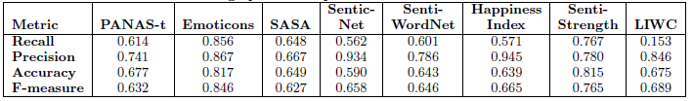

Figure 9 Differences In Sentiment Library Accuracy [48]

“Computer-Assisted Content Analysis: Topic Models for Exploring Multiple Subjective Interpretations” (Chuang J, Wilkerson J, Weiss R, Tingley D, Stewart B, Roberts M, et al. ) [33] is a paper written and published by the Princeton university. This paper discusses computer aided topic modelling from the perspective of allowing experts to interact with the creation of topic models in order to increase accuracy, reliability and adaptation of automatic model creation.

The paper discusses the limitations of topic modelling such as how multiple runs of a topic model can result to having multiple different solutions due to the underlying optimization [9]. Another point of conflict of topic modelling is that the output of models must frequently be manually updated which can introduce significant changes in the output produced as well as it has the possibility to replace the initial coding instructions that have been set up by the expert. Experts have rejected up to two thirds of the machine-generated topics [10]. Linking back to the first chapter, the limitations of topic modelling must be addressed. Particularly, the need for manual intervention in order to generate topic names. This problem seems to still be in effect with ideal solutions still not completely available.

Solutions are then presented within the paper that are focused on increase the usability of topic modelling in order to maximise its advantages. The first solution is to create high quality iterative models through the exploration of model space suited for their specific type of analysis. Unless this specific model can be manually constructed, manual coding will prevail in terms of accuracy, although it will still lag behind in being able to analyse large amounts of texts as content analysis is notoriously time and labour intensive.

The article also hypotheses that the visualisation of the topic model will reduce selection bias by the individual that writes the coding scheme. Generally, when picking codes in thematic analysis bias can occur when picking certain coding scheme and through the use of developing automatically generated coding schemes a large exposure to more coding schemes will increase the reliability of the coding implemented by the analyser.

Another recent article published at the start of 2019, which was briefly mentioned within the introduced, presents an implementation of LDA topic modelling that attempts to retrieve any discussion of thirdhand smoke within the Chinese Media [5]. The purpose was to discover how often the Chinese Media discusses this issue, how well it is discussed and how this has changed over time. A total of 2000 articles were recovered through the Wiser and Factiva databases.

An LDA topic modelling approach was implemented in order to discover the main keywords and topics discussed within thirdhand smoke articles. The percentage distribution for topics discussed are shown in the graph that has been added below (Figure 8) and the words that link directly to the topic have been added in the second graph (Figure 9).

The topics generated through the LDA model were performed on articles that only discussed third hand smoke and through using the word frequency distribution the LDA model successfully managed to create the words associated with its imaginary topics. Imaginary topics are created by the LDA model, but the LDA model does not understand the generic topic that the words link with. This dissertation did not focus on the automatic labelling of imaginary topics to their real-world counter parts and they were manually selected by hand. As discussed within the introduction, this is an objective that this dissertation will attempt to find a novel solution that will solve this underlying problem.

Findings within this article were able to determine that from 2013 to 2017 the number of articles written about thirdhand smoke has decreased from 78 a year to 41 a year within Chinese as opposed to the US where the number of articles increased from 52 to 105 respectively [5].

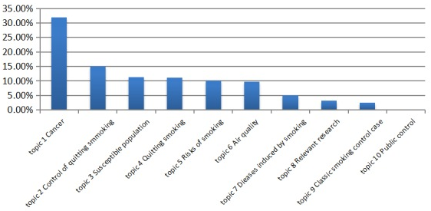

Figure 10 Thirdhand Smoking News Topic Model [5]

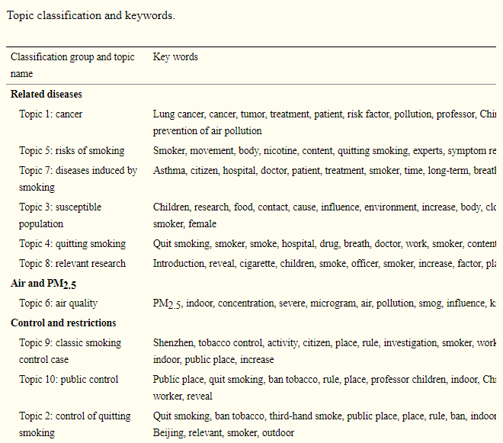

Figure 11 Topic to key word link [5]

#### 2.3.3. Bias Detection

Media bias detection in news articles is one of the most prominent areas of growth within sentiment analysis and ties in directly with this project. This area comprises of determining if certain news outlets display bias towards certain topics. Bias analysis is generally performed through the use of content analysis. [Marta Recasens](https://www.aclweb.org/anthology/people/m/marta-recasens/), an expert in natural language processing, developed a method to detect bias using a dictionary of words that is also used by Wikipedia editors to ensure articles conform to Neutral Point of View (NPOV) rules [12].

One such journal article named “Automated identification of media bias in news articles: an interdisciplinary literature review” [13] examines bias detection through comparing by what means various news outlets report events differently. No physical implementation of such a system is developed within this article, but an in-depth explanation of how automating such an approach could work is provided. This article also delves into the advantages of automating such an approach in order to escape the time-consuming process of manually linking events to a baseline.

This article explains that it first derives a set baseline through articles which are generally perceived to be the most objective, such as police reports [14]. Events that are reported by multiple media outlets are then specifically chosen to be analysed. Two studies discovered that the volume of participants and the event type such as protests against legislation had a high impact on the number of news coverage by different media organisations [15].

To automate the above approach a sequence of steps was required. Firstly, relevant articles on events must be recovered, the articles must then be linked to the baseline data such as police reports and then statistics must be computed on the linked data.

The diagram below demonstrates the events that were examined based on different publishers across countries. The event in this scenario was where a publishing company in a country mentioned one of the four countries below (USA, Russian, Great Britain and the United Arab Emirates and Ukraine).

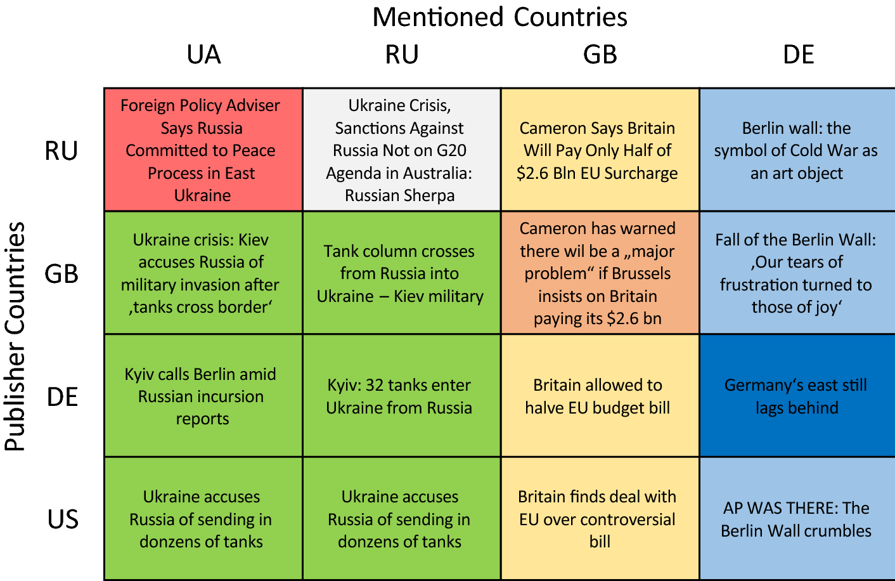

Figure 12 Publisher Bias Detection [13]

Another research projected developed within the Samsung R&D Institute focused on the implementation of a system that acts as a bias awareness news recommendation system. This system was built on the premise of scraping multiple news articles on a variety of topics from various news sources and then performing clustering on similar topics in order to calculate a bias score for each topic. The user can then generate a bias score for the article they are currently reading, as well as articles that are similar out of the previously web scraped articles.

The system architecture provided by the bias detection system is presented below. Newly created news articles are firstly scraped across multiple publishers, this is represented by the “crawler” and the content extraction is performed in order to obtain the articles and metadata such as which news company reported on the article. Topic modelling is then performed to construct the topics that were discussed followed by topic indexing which is effectively mapping the real topics to the imaginary topics created. Bias computation is then performed through a REST API. Firstly, the article is extracted based on topic, data cleaning and tokenization is then performed, passed to the REST API which returns an estimated bias score. The scores are than averaged across topics and sent to a database. Queries are then performed on this database each time a client accesses an article where a similar process occurs for that single article where it is compared to the other articles that discussed the same topic.

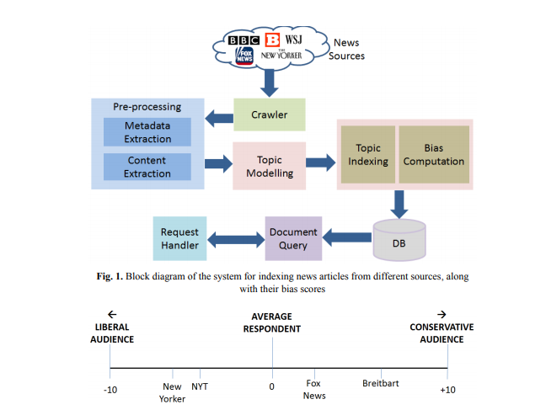

Figure 13 System Architecture for Bias Detection [16]

#### 2.3.4 Fake News Detection

“Is the News Deceptive? Fake News Detection Using Topic Authenticity” [17] is a paper that proposes an approach in order to detect fake news in online social media using a machine learning classifier. The machine learning classifier detects certain key pieces of information within the account in order to check if the account posts fake news.

The approach firstly checks if the profile and background image or description indicate that the news company supports one side on a controversial issue as many fake news sites have this characteristic. If this is found to be true the news company is automatically assigned as fake news. The next step checks if the profile description indicates it is a news feed. If the profile is a verified account it is legitimate, but if it is not tweets should seem to be objective and have retweets cited from reliable accounts. There is some discrepancy as to whether or not the account can then be labelled valid or not as the news account could be very small and missing retweets from verified accounts as few people are subscribed and regularly read the accounts posts.

On the one hand the approach applied to tweets within this project would not directly be applicable to the system described in this dissertation as it attempts to use specific information from twitter such as retweets as well as profile images which do not exist for popular newspaper companies. On the other hand, the machine learning and classification model has multiple points of interest that are still similar to newspaper stance detection. The project proposes a novel approach in finding similarities between fake news accounts such as average post length, average retweets and linking predications between max and total friends of accounts. The application within stance detection could be to build a similar model in order to find similarities with newspaper companies that are biased. These similarities could also be factors such as common headline terms, average article length and average number of topics discussed. This approach has a large amount of potential as no approach uses this metadata in order to build bias predication and while it may be inaccurate at times it has the potential to introduce novelty to the approaches that have already been developed.

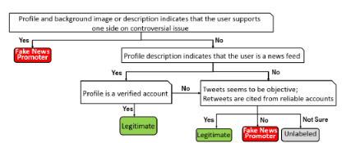

Figure 14 Manual Labelling [17]

## 2.4. Technologies you’ve researched

As per the discussion within the introduction, the key objectives are to implement topic modelling, data cleaning and a sentiment analysis that can be performed at large scale among thousands of articles. Consequently, requirements such as natural language processing libraries for data cleaning, lexical databases for understanding how closely words are linked and API’s for connecting to real Irish news source databases were investigated within this section.

The technologies researched consist of natural language processing libraries, existing lexical databases which apply components of text analysis, qualitative research approaches and API’s that can scrape newspaper articles.

#### 2.4.1. Natural Language Processing Libraries

Python is at the forefront of natural language processing (NLP) and there is a plethora of different NLP libraries that are integrated with python. Different libraries have different advantages such as performance, accuracy and a more extensive feature lists, while others have specific trade-offs. The scope of this section is to discuss the most viable natural language processing libraries and single out the libraries that are most suited to this system.

The first natural language processing library that was uncovered within the research phase was NLTK or the natural language toolkit which was developed in python. This library provides a large suite of libraries for symbolic and statistical natural language processing within the English language. Advantages of this library include consistent use of data structures, extensibility to other third-party NLP languages, modularity between interactions of the components within the system and a through documentation. [18]

“SpaCy” is one of the fastest NLP languages that integrates the C programming language for some of the more process heavy tasks. A paper written in 2018 investigating “SpaCy” performance and made the follow claim. “We employ the POS Tagger of SpaCy, in preference to the CMU TweeboParser, due to the heavy processing time of the latter. The TweeboParser was 1000 times slower as opposed to SpaCy” [19]. Spacy also provides more advanced features than libraries such as “TextBlob” such as entity linking and working with vectors.

“TextBlob” is an NLP library that extends the NLTK library and provides additional functionality such as noun extraction, word tagging and text classification. “TextBlob” is generally the library of choice for beginners within the area of NLP as NLTK itself can become very tedious for completing even simple tasks, whereas “TextBlob” can achieve even more complex functionality through a simple interface, the draw back being that TextBlob is slower than NLP languages such as SpaCy and less advanced in the feature suite that it provides. [20]

Scikit-learn is another NLP library that performs a wide array of both natural language processing and machine learning. This library focuses more than any of the others on machine learning having natural integration with classification, regression, clustering and model selection. The advantages of this library are the wide array of various applications to machine learning.

Figure 15 Sci-learn Machine Learning Applications [21]

Gensim is an open-source library for unsupervised topic modelling and natural language processing implemented in python. As seen in the previous section, a great deal of research projects uses genism in order to establish various models within natural language processing. Genism also has integration in order to assist in the extraction of semantic topics from documents in an efficient process. Gensim can work both with topic modelling and sentiment analysis with it’s well optimized Word2Vec and Doc2Vec support.

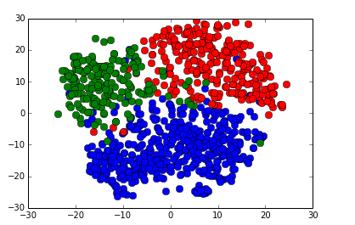

Figure 16 Gensim Classifier with food words (blue), sports words (red) and weather words (green) [22]

#### 2.4.2. Natural Language Tools

Wordnet is a large English lexical database containing nouns, verbs, adjectives and adverbs which are grouped into sets of cognitive synonyms (synsets), each expressing a specific concept.  Synsets are interlinked by means of conceptual-semantic and lexical relations. [23] A lexical database such as wordnet is required in NLP as data cleaning processes such as lemmatization require breaking down each word into its normal form, removing prefixes and suffixes. This is a complex task that requires the assistance of such a lexical database.

WORDSEER is another online resource with an exposed API that performs textual analytics and visualisation to make text navigable and accessible. It splits phrases, nouns, years and even specific metadata such as the names of presidents from within texts.

Figure 17 WORDSEER Visualisation of Text

#### 2.4.3. API’s

For data training the prototype the “20 News Group Dataset” “BBC dataset” were considered. The “20 News Group Dataset” was chosen as a result of it having a simpler structure allowing it to be more easily parsed.

For acquiring real life datasets several API’s responsible for retrieving newspaper articles were investigated. The most powerful was “newsapi.org” that links directly to Irelands live top and breaking news headlines and articles. The data recovered is in json but an issue that was discovered with this API is that there is a limit of 500 requests per day and only articles up to one month old can be retrieved for the free version. This may not be a crucial issue as within one month of making 500 daily requests, over fifteen-thousand news articles from Irish papers can be retrieved. [24] After further investigation it was discovered that unless this API’s was payed for in a subscription, it would only return the first 180 characters of a newspaper making it unusable for the purpose of this project.

Another news API is the “MyAllies Breaking News” API that provides the access to real time news from across the glove. This API is completely free to use on RapidAPI and overcomes the previous limitation, but it does not have access to articles older than a single day.

A possible solution to overcome the limitation of a maximum of 500 requests a day is to implement a web scraper that can that can retrieve the textual information from articles daily.

## 2.5. Other Research you’ve done

## 2.5.1. *Research of Bias in Media*

Research of the exact steps of how bias occurs within media is a quintessential step in understanding how to build bias detection for news outlets. This research aids in mapping the sentiment score to each topic as it allows the creation of an estimation of how much bias naturally occurs within the media.

The diagram below shows the process of how bias is formed within the media. It firstly breaks down the factors that influence the medias perception. The political and ideological view of the company naturally influence how various topics are represented and this consequently will affect and skew the representation of political parties and movements through bias. However, factors such as advertisements will skew sentiment greatly. Different articles can quickly switch between persuasive and informative quickly, where persuasive should generate outliers that have a very high sentiment score and informative could have an overly prevalent neutral score.

Owners will affect in how articles report on events as the news company might not report negatively on an event involving one of their partners, advertisers or sponsors. Another large factor that influences media representation is target audience. Target audience is a major factor as generally papers attempt to cater to the views and beliefs of the group that reads the paper in order to continue their readership of the paper and as a result this is another factor that effects media bias.

As can be seen in the centre of the diagram there are a lot of natural factors that further effect bias without considering opinionated bias. There can be discrepancies between different news companies and the gathering of data. Different news companies may be mis informed or miss key facts that will affect the writing style and generate more negative sentiment scores that other news companies even if they share the same perspective. Writing style can be more negative or positive for certain journalists as writing styles different. Local colloquialism would also make the sentiment analysis incapable of classifying the expression and generating a score as it may not have classified such phrases.

Finally, editing is a major contributor as it can both reduce and increase bias. Some papers may specifically remove certain words that are overly positive or negative with a more informative style of writing was required. Another factor within editing that effects bias detection is where miss spelled words are missed. Sentiment analysis cannot work on words that are miss spelt and as a result no sentiment score can be generated, and bias cannot be caught or dismissed.

Figure 18 Bias within Media [13]

## 2.5.2. *Mapping of Imaginary Topics to real world Topics*

An issue that has been an obstacle for LDA topic modelling is its inability to accurately label the topic name of topic models. While the topic model can group words that share a similar theme, it usually connects them to an arbitrary number such as “0” and this is known as its imaginary topic. From context, the analyst then manually labels the names of the topic based on the words. A machine learning model fails this as the range of interpretations that can be taken of mapping specific words to their generic category is currently too complex. While existing solutions do attempt to solve this issue, many of them fail and are still considered sub-optimal due to their large degree of error. Many dissertations, books and articles have spent many years in an attempt to find an accurate solution.

The automatic mapping of imaginary topics to their real-life counterparts is one of the most difficult areas within this project. As discussed in the first chapter, this issue will be tackled and a novel solution will be pursued in order to automatically map the imaginary topics.

The publication *Automatic labelling of topic models* introduced a novel approach to label imaginary topics using Wikipedia articles. The authors theorised that if the top-10 topic terms within a topic were queried using Wikipedia articles, the titles of the Wikipedia articles could be used to identify the most generic topics. [49] This approach relies on the large volume of Wikipedia articles available on the internet, as well as the topic itself being well defined and relatively generic. The results found that it was uniformly better then unsupervised baselines for four different datasets, but the study overly relied on very basic topics such as “Books”, “News” and “Blogs”. These topics are not reflective of this project as topics will be less generic such as presidential candidates where the top ten terms may include the candidates’ names but they will also often include extremely generic words such as “election, campaign and vote” which make it difficult to identify that the specific topic is a presential candidate, but more than likely make a generic assumption and simply return a generic topic such as “presidential candidate” or “election”.

The article *Automatic Labelling of Topic Models Learned from Twitter by Summarisation* proposes a multi-document summarization task to characterise documents relevant to a topic. While previous work has shown that labelling a topic with the top most used words is not always representative of a topic [51], this approach relies on term relevance relating to a topic using summarisation algorithms which intendent of an external source, provided a higher performance than the top-n terms base line created by unsupervised learning techniques [50].

The diagram below outlines the various different approaches tested within this research project. Research found that the frequency-based summarization techniques *(Sum Basic)* out performed graph *(Text Rank)* and relevance-based *(Maximal Marginal Relevance)* summarization techniques for generating topic labels [50].

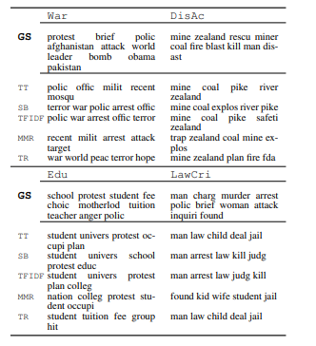

Figure 19 Summarization Topic Labelling [50]

Many more approaches to topic labelling have been implemented, each with their own trade-offs such as using word vectors and letter trigram vectors, [53] using neural embeddings to label a topic with a succinct phrase that summarises a theme or idea [54] and many more novel solutions. Both vector and letter trigrams as well as the summarization of themes using neural embeddings seem to still not accurately labels topics with sufficient accuracy to be reliable in most scenarios. For this reason, the limitations and conclusions will be evaluated when constructing the approach to topic labelling in order to make the topic labels as accurate and dependable as possible.

Approaches that are considered after evaluating the literature review include finding the hypernym of the top weighted words within a topic distribution and labelling the topic with the top weight hypernym words, using a semi-guided machine learning technique to label the model with an external data source or a mixture of topic labelling algorithms that were reviewed to see if accuracy is improved.

## 2.6. Existing Final Year Projects

Several final year projects from previous years were looked at in the research phase of the project. The elimination process for choosing final year projects to investigate was finding similar themes such as natural language processing, sentiment analysis and machine learning.

*Sentiment and Mood Interpreter for Logging Emotions*

This final year project primarily focused on sentiment analysis for positive and negative moods. The sentiment analysis was performed on facial recognition (which was found to be 79% accurate) and diary entries (which was found to be 40% accurate). A large portion of the project also focused on the design, layout and usability of the application itself.

The application was designed using feature driven development with agile methodologies. Similarly, for the topic modelling within this dissertation, an iterative approach will also be essential as it will demonstrate a steady growth in the accuracy of the topics built. The feature driven approach will not work as well for this final year project as it will essentially focus on a few features and the complexity will follow from how they link together. For example, linking sentiment and topic analysis to determine sentiment towards certain topics.

Testing was implemented using percentage scores for facial / emotion detection and sentiment analysis. An iterative approach was then followed for monitoring how the percentage score changed as the analysis became more accurate. Edge cases that reduced the accuracy of the results were also flagged and different scores were built around them. An example of such an edge case is where the facial recognition is used in a dark room and in this scenario the accuracy of the facial recognition would have its own independent score rating.

*NLPurchase – eCommerce Chatbot Final Year Project Report*

This final year project makes use of natural language processing in order to make a chatbot that can successfully communicate with a customer on an eCommerence website. Natural language techniques such as lemmatization and removing stop words are used in order to break down the contents of the users input and allow a more standard, readable approach. In this newspaper topic and sentiment analysis thesis these data cleaning techniques are crucial, particularly for the topic modelling where thousands of newspaper article will each individually be scanned into memory and then split into a very large list of words where further analysis algorithms will be completed to extract meaningful topics and sentiment scores.

The design of the final year project followed an incremental cycle in order to allow the project to adapt to change, as well as provide continuous prototypes with simple complexity that gradually evolved over time. This design allows the project to be split into multiple stages, avoiding architectural risks very early in development as no crucial decisions are made very early in the analysis of the project.

Testing was performed continuously though user integration. A mixture of informal and formal testing was used. The informal testing was where multiple users between the ages of eighteen and twenty-four used the chatbot and multiple stages of its development and cycle and were proposed to fill in their criticisms, issues and proposed solutions when using the chat bot. The users would also give overall usability scores. The formal testing was implemented through a survey which contained questions based on the chatbot design guidelines. These guidelines compromised general usability and feature functionality.

## 2.7. Conclusions

With the knowledge and conclusions drawn from the literature review, the designing and development of the system can begin. The crucial learning from this research provided a stronger understanding of the current technologies and applications within this area as well as their advantages and disadvantages. Furthermore, a better grasp of what can currently be achieved with LDA topic modelling and sentiment analysis within the media has also been ascertained.

This chapter has also further established the requirements necessary that will be discussed within the following chapter. Natural language Processing techniques will need to be designed in order to introduce an efficient and powerful data cleaning algorithm and a suitable LDA model will need to designed in order to produce accurate topics from the distribution of words.

The large scope of projects presented within this field also demonstrates how this field is currently an area of relevance. Multiple dissertations, papers and conferences over the last couple of years have been dedicated to further exploring this topic and unlocking more powerful tools and applications of this technology.

# 3. Experimental Design

## 3.1 Introduction

Connecting back to the previous chapter where the literature review was presented and evaluated, the themes will be continued and deeply integrated within the design chapter where the key learning points will be applied from the analysis of different technologies, similar systems and failed approaches.

The first section will look at the software methodologies employed in the creation of this project and then an overview of use cases will be created. The following section will analyse the system architecture from the perspective of the front-end, middle-tier and back-end.

Prototyping will be a key technique within the life cycle of the design and the development process. As the development continues, new iterations of the prototype will introduce changes to the design in order to adapt to the changing requirements as better approaches are discovered within the development phase. Linking directly to the incremental development methodology, prototyping is a technique which breaks a project into smaller portions with the scope of enabling simpler requirements. The strength of such a process is exemplified by Jason and Smith [42] where they comment on the users inability to identify their own requirements and as a result the need to exhibit the requirements of an experimental system such as a prototype in order to be able to more accurately estimate the requirements and the feasibility of the system.

## 3.2. Software Methodology

Multiple software methodologies were considered before arriving to a conclusion. Some of the methodologies considered includes the spiral and waterfall model, feature-driven development, extreme programming, and Kanban. Methodologies such as the waterfall method were instantly eliminated due to their well-known limitation of being unable to adapt to a changing in the requirements. As a result, the methodology of choice for this thesis was strictly required to be agile in nature and only the agile mythologies were seriously considered and examined.

*Spiral model*

Figure 20 Spiral Model [32]

The spiral model is an agile methodology that is provides a several useful advantages that fit this project. It has one of the best risk analysis models as it is performed iteratively on each iteration. It also provides a realistic implementation as the project moves through loops in a spiral development process to be completed. As discussed in the literature review within the section 2.4.1. “Qualitative Analysis Research”, the continuous iteration of codes and themes is extremely beneficial in order to better understand the data as many mistakes are initially made when understanding the data and it is only after a stronger familiarity with the data is made, that the codes and themes can be reliable, making the spiral model particularly useful in qualitative analysis research.

The disadvantages on the other hand bring in a costly model where a great deal of time is spent on each stage of the design and iteration process. The risk analysis also requires a highly specific expertise in order to design and deeply analyse each iteration. The spiral model is also particularly fine-tuned for large projects that span multiple teams and since this project will be independently completed it may not be suitable [35].

*Feature-driven development model*

Figure 21 Feature-driven development model [36]

Feature-driven development supports industry recognized best practices, breaking down large projects into smaller features and a simple five step process than does not require a specific expertise. Disadvantages include an iterative process that is not as well defined as other agile methods and generally this methodology is not suited to a single software developer, but multiple teams working in parallel.

A key aspect of feature-driven development is its emphasis on communication between teams and collaboration between users. This thesis is not an application and will not go deeply within the area of human computer interaction. As a direct result a lot of the design principles behind feature-driven development stray away from this projects core focus and would not be suitable for this thesis.

*Extreme Programming*

Figure 22 Extreme Programming Model [30]

Extreme programming is an agile methodology that follows specific programming guidelines such as test-driven-development, continuous integration and prototyping. This methodology focuses far more on writing code than in very short iteration cycles where short tests are continuously integrated within the development process and while the design is left more lacking than the previous methodologies the level of testing done acts as its own documentation and analysis. Disadvantages include a requirement for skilled programmers that can conceptualize a large portion of the design and work independently or in pairs. Another disadvantage is the reduced level of design may lead to a larger risk within the project’s development for edge cases.

*Kanban*

Kanban is an agile methodology that splits tasks into achievable blocks. It encourages continuous integration where all the work and progress are reviewed daily, providing powerful goal orientation and progress reports. These reports provide meaningful data that allows the developer to stay on track with continuous planning and analysis of progress,

Figure 23 Kanban Progress Chart

Figure 24 Kanban Example [31]

*CRISP- DM*

The Cross Industry Standard Process for Data-Mining is a model that is commonly used to solve machine learning problems [44]. This is a fine-tuned model that focuses on understanding data, pre-processing data and finally training and testing the model.

This methodology fits this project very well since the majority of the complexity within this thesis resides around the iterations of building the LDA topic model in each phase. This will compromise around understanding the requirements and cleaning the data and then training and testing the specified model.

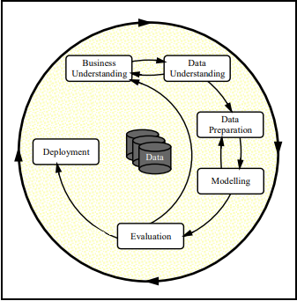

Figure 25 CRISP-DM [43]

## 3.3. Overview of System

Aspects from the Kanban, simplified spiral model and CRISP-DM methodology will be introduced within the development of this project. Each iteration will introduce a specific set of the key elements from each design methodology. The spiral model will be responsible for extracting the risk analysis and engineering testing methods. Kanban will be responsible for goal orientating each iteration, timeboxing using the Pomodoro technique as well as evaluating the success of each iteration continuously and finally CRISP-DM will provide standard machine learning specific approaches to mining, understanding, preparing modelling and evaluating the data.

Both design and code will be delivered in stages to allow an adaptation to change in each iteration. The following features will need to be completed and then iterated over to be made more accurate and provide more meaningful data.

1. Sourcing of training data to test the models.
2. Sourcing of real news articles with various topics from multiple media outlets through an API or web scraper.
3. A data cleaning algorithm that will implement natural language processing techniques to prepare the data for the sentiment and LDA topic model.
4. An LDA model that can accurately generate topics.
5. Methods to test the accuracy, coherence and perplexity of the LDA topic model through stages.
6. A mapping of the created imaginary topics to its respective real topics. (As discussed in the literature review, this will be a complex area in itself that is difficult to accurately implement with current technology).
7. Multiple methods to visualise the topics created by the LDA algorithm.
8. A sentiment analysis model.
9. A mapping of specific sentences to each topic.
10. Aggregating a specific sentiment score for each topic.
11. A database to store the average sentiments for media outlets.
12. A display for the various average sentiments for each topic per represented media outlet.

The architecture does not rely on any client-server model. The complexity is sourced within the area of building topics from real newspapers and being able to map the topics to a sentiment score that reflects that newspaper companies’ views towards these topics. Initially this system was designed to have no database due to CSVs providing the ideal method for reading and graphing data, but due to the decision to use Grafana or wave front for displaying the results, a database was integrated in order to feed this information through Grafana’s API natively. This in turn orchestrates a non-traditional approach for the interaction of the front, middle and back-end of the system. This is as a result of the logic layer only interacting with the database in order to upload results, rather than consume information, and then the front-end only consuming the data from the database in order to display the results without having any interaction with the middle-tier.

The diagram below shows the interaction of the different layers and how the logic layer is not at the centre interacting with both the database and logic layer. The advantage of this model is that the results can be streamed in real-time to provide time series data as to how sentiments change over time and provide more information.

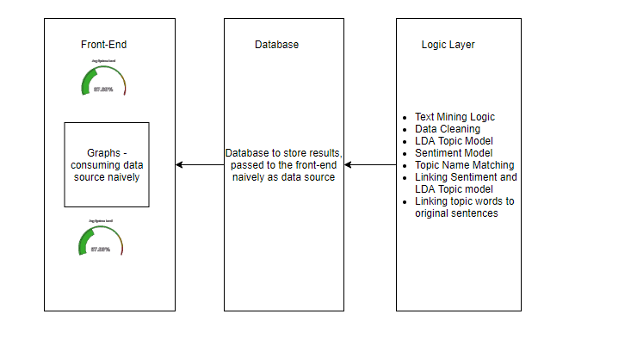

Figure 26 System Design

The diagram below shows a high-level sequence of events that occur within the system when generating the sentiments of topics for each newspaper company. The processing is performed in stages where first both the training and real newspaper articles are sourced. The training data is then cleaned and an LDA and sentiment model is built using this data. The models will then be used on the real newspaper articles in order to split the topics again and build a sentiment score around each topic.

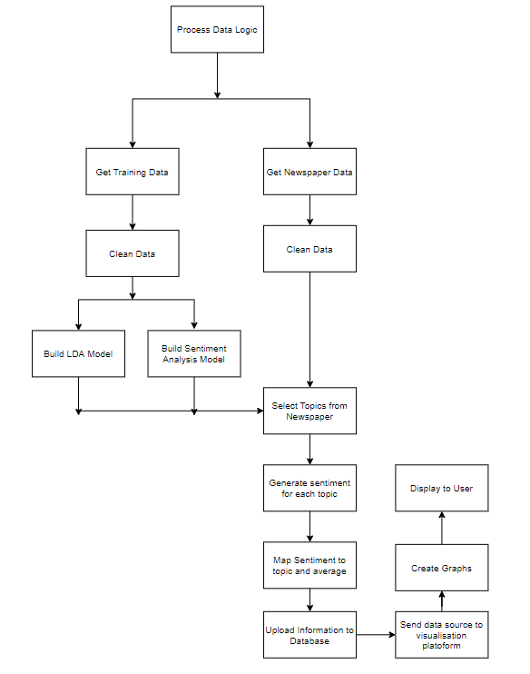

Figure 27 System Sequence of Operation Diagram

## 3.4. Design of User-Display

The front-end layer will focus on displaying the slant and bias of news media in regards to various topics through their aggregated sentiment scores. A textual representation of data will be provided, but the main user display will be presented using a multi-platform open source analytics and interactive visualisation software. Multiple third-party libraries will also assist in visualising the created topics within graphs in order to provide more granular information for how the topics are represented and to provide further insight into the quality of the created topics. The distance between topics and which topics are the most dominant and representative will also be visualized.

A dashboard will be created inside of a visualisation software such as Grafana or Wavefront in order to display most of the representative graphs. The sentiment and objectivity scores will be created separately for each news company and the mode, average and median will be calculated as well as attempts to increase the amount of information available in displaying the data.

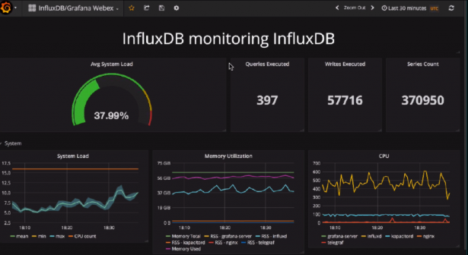

Figure 28 Example Grafana Dashboard [55]

There will be many graphs that will be used to dictate the quality of the created topics, rather then the stance of media outlets and these are essential in order to form a better understanding of how the sentiment analysis was performed on these topics, as well as the significance of the results. Below I will discuss some of the different graphs that are planned to be implemented within the development phase.

Displaying the word frequency in each topic may also be useful to determine the dominance of each topic as discussed within the literature review. The choice of graph could be a histogram as it is one of the most informative and clear graphs in attempting to determine the total word frequency within a topic.

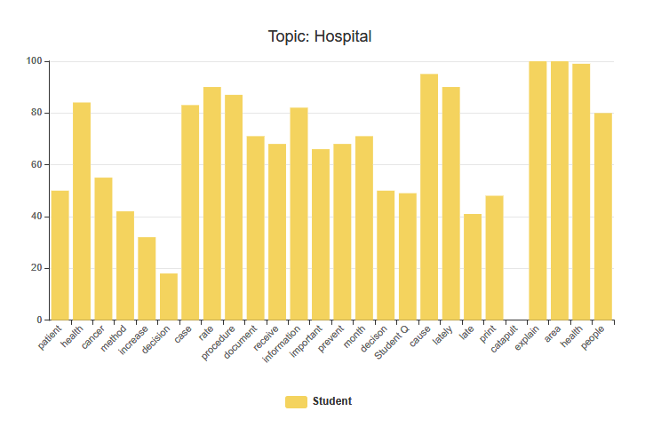

Figure 29 Word Frequency Topic Distribution Histogram

Below is a hand drawn design for how topics will be displayed in the LDA model. On the left a graph shows all the topics with numbers designating a topic. The larger a bubble the more commonly this topic is mentioned within the media. On the right is the display for a topic (9) which links to hospital as can be seen through the correlation of words such as patient, cancer, information etc.

Initially the LDA display does not process and correlate the imagery topic (which is the number) to the real topic as further processing and implementation is required to link it to the real topic. The distance between topics also represents how far away each topic is from each other. This is calculated using the similar words that are shared between topics. For example, if two topics were football and basketball, then they would be tightly linked as multiple words would be shared between them such as “lose, win, team”.

Figure 30 Hand drawn Topic Display

## 3.5. Design of Functionality

The middle-tier is the logic layer that drives the system and implements its core capabilities and it is this layer that the complexity from this system arises. The middle tier will implement the newspaper scraping responsible for sourcing relevant newspaper articles from various media outlets, the natural language processing, the data cleaning, the latent Dirichlet allocation topic modelling and the sentiment analysis as well as the mapping of imaginary topics to their real life counterparts, linking the words from the topic model to their respective sentences and finally calculating the representative sentiment scores.

The use case diagram below shows the different pieces of functionality available to the user. The first piece of functionality allows the user to view the overall sentiment towards a topic created by the LDA model which provides more in-depth information such as the words used. The second option allows the user to see all the topics and sentiment scores generated with a clear interface such as Grafana. Finally, the last option shows all the topics without sentiment scores. This option also provides more information on the topics themselves such as what words make up that topic.

Figure 31 User use case diagram for viewing topics and sentiment in media

A suitable method will be required to scrape newspaper articles from API’s and where API’s are not available through an inbuilt web scraper that is targeted at specific media outlets. Due to the large amount of data required it is likely a thread capable web scrapper will need to be implemented in order to decrease the time it takes to capture large amounts of data, especially in order to build the LDA topic model.

The technical architecture for data cleaning below shows the data processing required in order to apply the LDA model as well as the sentiment analysis model. This step is pivotal in natural language processing as the data needs to be cleaned in order to efficiently and accurately create the models. Within natural language processing the more work that is performed in the data cleaning layer, the more accurate the models will be and developing a more accurate and efficient data cleaning algorithm will be a future concern in order to increase the accuracy of the model.

Figure 32 Process for Data Cleaning for Sentiment Analysis and LDA Topic Modelling

The implementation will require multiple natural language processing techniques as can be seen in the diagram above. Some of the techniques are straight forward such as removing punctuations and can be implemented with simple regex commands and other techniques require additional assistance from third party libraries. As an example, lemmatization will require removing all suffixes and prefixes from every word and transforming them into their neutral form. This is a complex area in natural language processing and contains a large amount of edge cases and complexity which are cumbersome to solve manually. A more feasible solution is to investigate and find an optimal library that balances speed and efficiency in order to perform the lemmatization on every word within the newspaper articles.

Building the LDA topic model will require the creation of a word dictionary that maps each word to an ID and corpus, which maps each ID to the frequency of each word. The sentiment analysis model will need to classify each topic and generate an average score for each topic. Mapping the sentiment score to each topic will then need to be implemented. This will be difficult as the models will be created separately and some method to link them will need to be created.

This system will not require a central database for the creation of the models, as simple text or CSV files are sufficient. The only source of information this project requires will be newspapers to train and apply models which are already in a textual format. The database that will be created is purely needed to feed the data to the Grafana API natively.

For the purposes of version control GitHub will be used. The iterative approach will be tightly linked to Kanban in order to keep track of progress through Pomodoro’s, the tasks that need to be completed, the tasks that are completed and useful resources.

Figure 33 Author's Dissertation Kanban

## 3.6. Design of Backend

The backend is only necessary to store the sentiment data for news companies, so that it can be sent through Grafana’s native API as a data source. Grafana is normally used for representing times series visualizations and this information is normally sent using time series data sources such as Prometheus and influx DB. MySQL is an alternative data source that can avoid storing the timestamps of when the information was received and furthermore represent the data without the dimension of time making it ideal.

The scheme has no logical relationships and while NoSQL would be ideal due to the performance increase, Grafana does not support NoSQL at this time. The database will be a simple table that the attributes for individual news companies such as average sentiment, average objectivity and the topic names.

## 3.7. Conclusions

Through the analysis of multiple agile methodologies, a mixed approach seems to be the most suitable for this thesis. The methodologies that will be employed include Kanban for task scheduling and progress management, a more basic spiral model for risk analysis and CRISP-DM as it follows the exact approach this system will be taking for text mining, creating models and finally evaluating the data.

Kanban and the spiral model will allow for early prototype development, the ability to adapt to change and monitor the completion of each task as well as setting and monitoring goals as they are completed with multiple progress reports generated by the Kanban tool to monitor progress. CRISP-DM will focus on the design of each step with how data is processed and prepared.

The design of different visualisation methods was discussed in order to determine the best methods for visualising the results as well as creating visualisations to improve understanding the accuracy of the created models. The functionality was designed in order to best suit the requirements and create an accurate representation of news outlet sentiment and objectivity. The key learning points from within the literature review were considered when designing both the front-end and middle-end of the application in order to reduce possible risks within development.

Based on the key themes that were discussed within this chapter, the following chapter will delve into the development process and many of the issues covered in this chapter will be revisited. The development chapter will discuss the implementations of the design and any challenges or changes that developed as a result of implementation limitations.

# 4. Experimental Development

## 4.1. Introduction

This chapter will begin the outline and implementation of the final year project that was discussed and planned within the previous chapters. This chapter will also discuss the key challenges faced within the development process due to unforeseen problems and resolutions that stray from the original design.

As discussed within the design chapter this projects methodology is based on using a mixture of the simplified spiral model, Kanban and the CRISP-DM approach in order to adopt the best features that fit this project from each design methodology. The development will be carried out in multiple iterations with the use of prototypes for each new feature that will at first implement the basic functionality with limited accuracy and improve on each feature over new iterations. Kanban will be used for managing goals and the allocation of time on each feature and the specific methods employed for the implementation of text mining and the creation of models will prescribe to the CRISP-DM methodology.

## 4.2. Technical Architecture Summary

As mentioned within the design chapter, the architecture for the system follows a non-traditional approach in that the front-end will consume a data source such as the database natively and the logic layer (or middle-tier by convention) will be responsible for the creation of this data. The data is uploaded to the database and has no direct interaction with the front-end. The diagram showing the relationship between the tiers can be seen here.



Figure 34 System Design

The projected was implemented in the python language, version 3.6 and Java libraries were integrated to make further improvements to the LDA topic model using Java 8. Multiple libraries were used in order to assist in natural language processing, creating the LDA model and visualising the topic model such as SpaCy, NLTK, Gensim and pyLDAvis respectively. The LDA model’s accuracy score was computed using both a coherence and perplexity scores.

## 4.3. User-Display

The user-display below is broken into two different subsections. The first subsection describes and showcases the sentiments of media towards various topics. The second subsection is for providing more granular information and displaying what constitutes a topic such as the words that make up a topic (with weights) and how dominant certain topics are in regards to each other.

## 4.3.1 *Media Outlets’ Sentiment Representation*

The representation of media outlets’ sentiment is implemented through Grafana, a multi-platform open source analytics and interactive visualization software. The two graphs that were used to display this information include bar gauges and horizontal bar graphs.

Bar gauges were used to represent average objectivity and mode sentiment due to the relative representation of different sentiments. In this instance, the gauge starts from the lowest sentiment score and rotates towards the highest. This provides a clear understanding of the differences between the which topics are represented the most positive and the most negative within a media organisation.

Both the bar chart and bar gauge sentiment scores have been truncated to start from zero in order to provide a clearer view of the differences in how sentiments are represented. The only topics that encountered a negative sentiment score were housing by the independent and drugs by the daily mail and drugs were significant (-4.7) which made the graphs less clear since it relatively measured the differences.

The first two figures represent the differences in objectivity per topic represented relatively to each other for the Independent and the daily mail. As can be seen when comparing the two figures, the Independent on average seems to be more objective then the daily mail in its use of language. Using this algorithm, the least objective topic for the Independent is the topic of “business” with an objective score of 0.22, whereas the least objective topic for the daily mail is the topic “online” with a score of 0.47.

The scores are calculated using the top ten weighted words within a created topic. As an example, the words that represent Trump are words such as “Trump, Campaign, Election, Candidate, Impeachment and so on”. These results do not completely map the objectivity of the news media to Trump as some of the words analysed are more general as is the limitation of LDA topic modelling, but when compared to different news outlets do provide some level of insight.

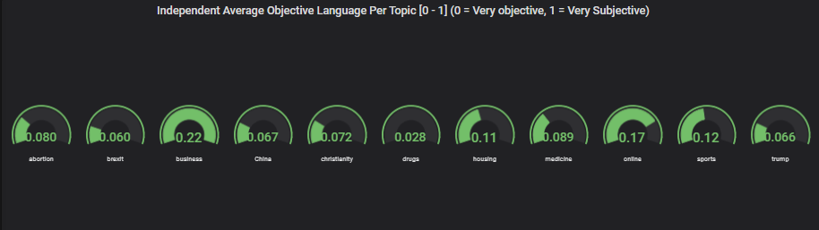

Figure 35 The Independent Average Objectivity

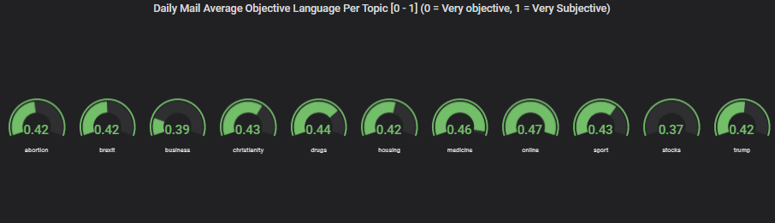

Figure 36 Daily Mail Average Objectivity

Horizontal bar graphs were used for displaying the average sentiment as similarly to the bar gauge graphs it also provides clear, relative understanding of how different topics were perceived by media outlets as well as clearly defining the relative differences in topic sentiment.

As can be seen in the bar chart below a more negative view was taken by the Independent towards Brexit than the daily mail and this lines up with the news organisations views.

For the topic of drugs, the more positive trend for drugs in the independent could be as a result of the Independent using significantly more objective language when describing drugs then the Daily Mail which can be seen clearly as the daily mail used an average objectivity of 0.44 when discussing drugs whereas the independent had an average objectivity score of 0.028 as can be seen in the diagrams below.

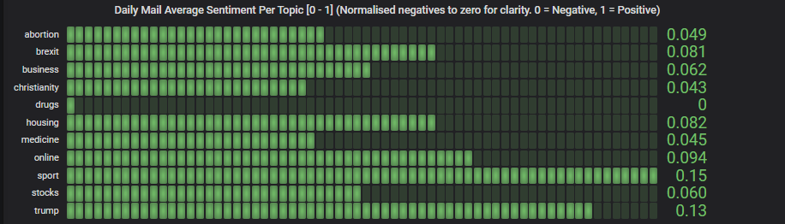

Figure 37 Daily Mail Average Sentiment

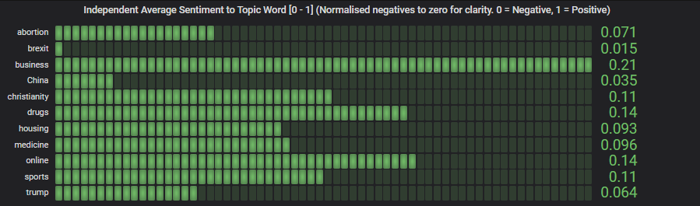

Figure 38 The Independent Average Sentiment

Bar gauges display the mode as the mode seems to step in “.1” increments and the bar gauges seemed to be clearer than the bar graph for representing this information.

The modified mode sentiment in this instance represents the sentiment that was most often displayed for each topic. The average can infer the general representation of a topic, but due to outliers it may skew the data inconsistently. The mode on the other hand will display how the topic was most consistently represented, regardless of outliers.

The results for the mode seem to be much higher than the results for sentiments above, and this is because the mode initially was either zero or close to zero for almost all of the topics, proving that both papers generally attempted to be more objective, but in order to better understand with the papers did use non-objective language and what their views were when not objective, sentiment results that returned zero were omitted and this is the data that follows. This data shows much more positive results for various topics due to the average zero results not skewing the data lower.

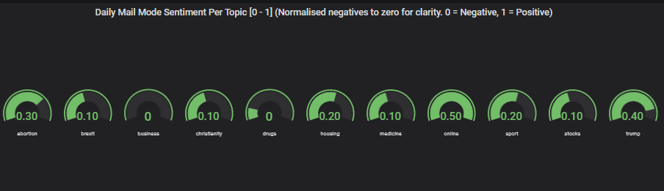

Figure 39 Daily Mail Modified Mode Sentiment

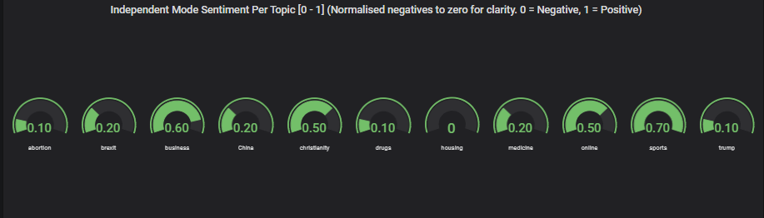

Figure 40 The Independent Modified Mode Sentiment

## 4.3.2 *Representation of Imaginary Topics*

This section discusses the layout for the display of the created imaginary topics, labelled as numbers. The display was created with the assistance of the pyLDAvis.gensim library which was specifically created in order to provide access to powerful methods for visualising topic models.

In the topic graph below, each number within the graph represents an imaginary topic with a list of words that relate to that topic. As an example, the topic which has been clicked is marked in red (42) and all of the words that are associated with this topic can be seen on the right of the graph. Words such as information, patient, cancer, cause and case instantly can be related to a hospital or health. Therefore, the number 42 represents this real-life topic of health or hospital and the algorithm which maps the imaginary number to the real-life topic is then ran to convert it using a probabilistic method.

The distance between topics represents how closely linked the different topics are to each other. As an example, the diagram below which represents the topic 26 is completely covered within topic 41s circle. This represents that there is a strong link between the two topics and when examining the contents of the two topics they share many words, however the words that are used are generic in 41 (would, go, make, think) and in 26 the words that are used are presumably from political articles where this more common direct speech from anecdotes is present (people, group, believe, speak, die) and many generic words are often tightly coupled. The interface shown below matches the hand drawn graph which was the proposed method for displaying topics in the design chapter.

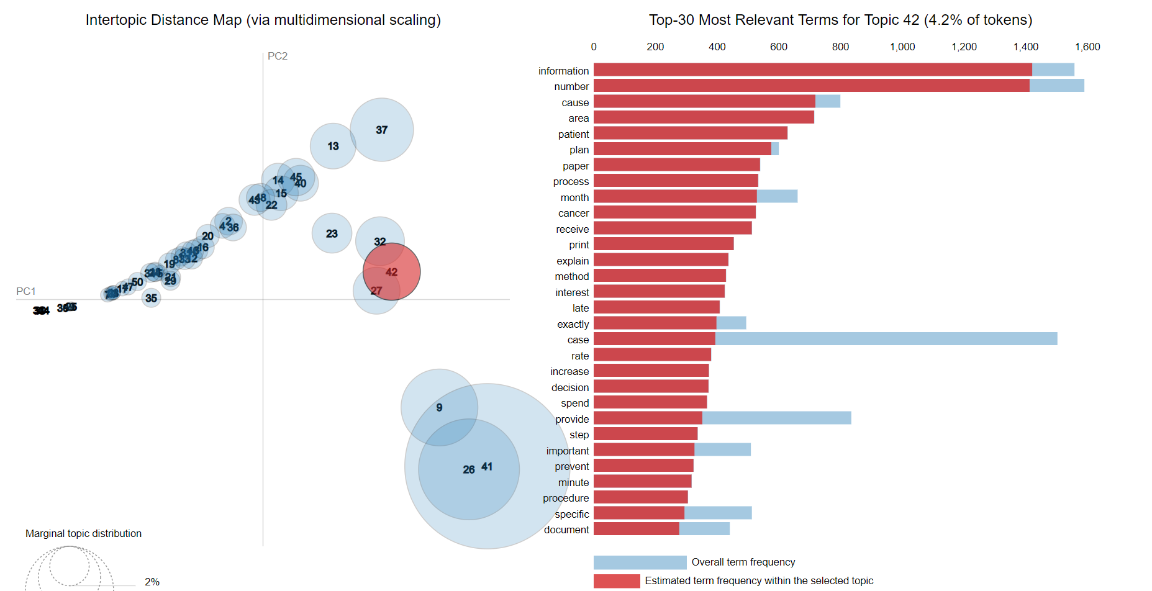

Figure 41 Topic Modelling Visualisation for Topic 42 (Hospitals)

The word count for each topic is also present within the graph, outlining how extensively different words are used within the various topics.

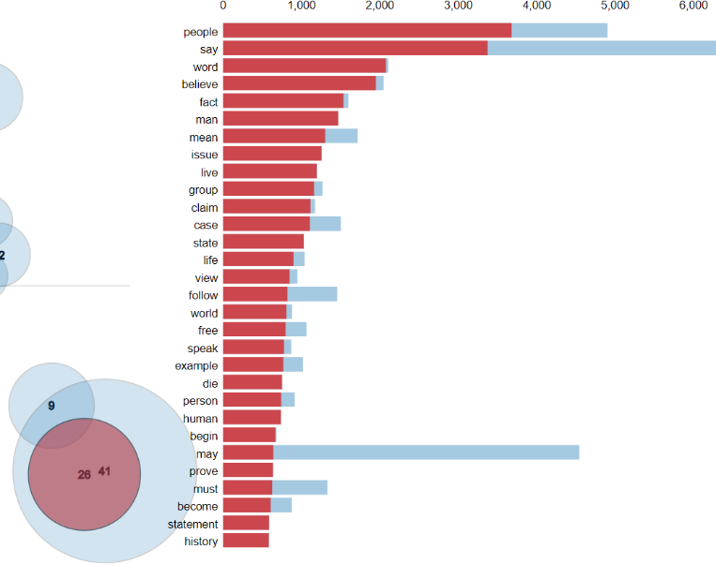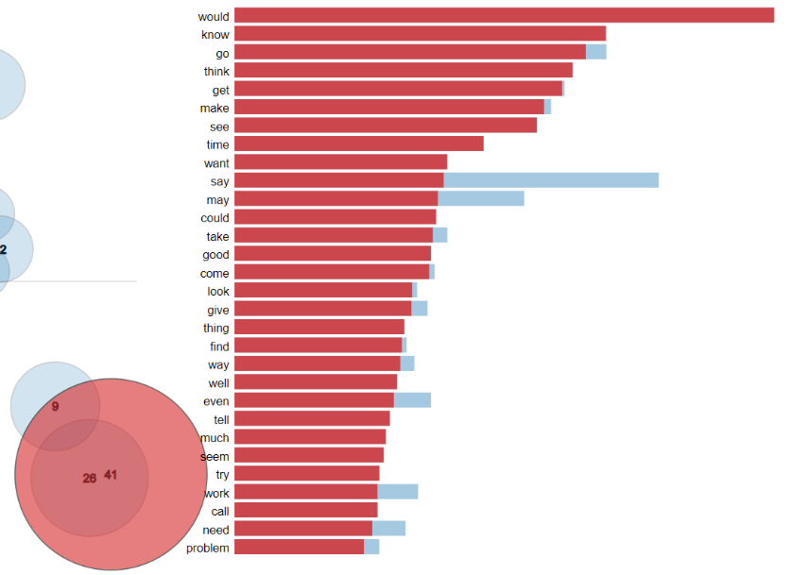

Figure 42 Topic Modelling Visualisation for Topic 26 (Politics)

Figure 43 Topic Modelling Visualisation for Topic 41 (Generic Words)

## 4.4. Functionality

The GitHub repository that contains the source code, models, html visualisation file and corpus can be found at the following link: [ADD LINK]

The functionality section is split into the following subsections.

1. Data Sourcing
2. Data Cleaning and Building the LDA topic model
3. Mapping Imaginary Topics to Real World Topics
4. Mapping Topic Words to Original Sentences
5. Drawing more Information from Results *and Improving Graph Representation*
6. Improving the Quality of Topics
7. Overview of Key Code

## 4.4.1 *Data Sourcing*

As discussed within the design section the initial scope of sourcing news articles was to use existing API’s such as the global newsapi found at <https://newsapi.org/> or news outlets own public API. Both these methods were not suitable for text mining for a number of reasons. Firstly, while the global news API is capable of searching news worldwide, unless the premium version is payed for it will only return the first 128 characters of any article, making it unsuitable for this project due to its high costs. The second approach of using local news API’s was also not possible for all news companies as very few news companies provide an open API that can be used to query their news articles. After further analysis, a more generic approach that could be used ubiquitously for all news organisations was required to be engineered.

The solution that was later decided on was creating a web scraper that would use REST standards. The web was designed to scrape URLs that relate to a specific topic and fall between a certain date to provide the relevant articles’ URLs. Once the URLs were scraped, the web scraper would then loop through each link for each news company, parse the articles for the title, content, author and date it was written and save them to an existing database. The architecture diagrams for both pieces of functionality can be found below.

Once the web scraper was created a new issue was encountered. The web scraper required hours in order to scrape the required number of articles for a news company topic and this was not permissible as it would take many days of scraping to download all of the required articles for just one news company. The solution introduced was to make the application multithreaded and the introduction of threads significantly reduced the speed it took to copy the articles on to the local machine.

Initially when threads were introduced, this created a new problem as there were hundreds of threads all attempting to access a news website at the same second causing short IP blocks that would only last a couple of seconds. To rectify this problem less threads were used and this stopped the news site from blocking the local IP.

**URL Web Scraper Execution**

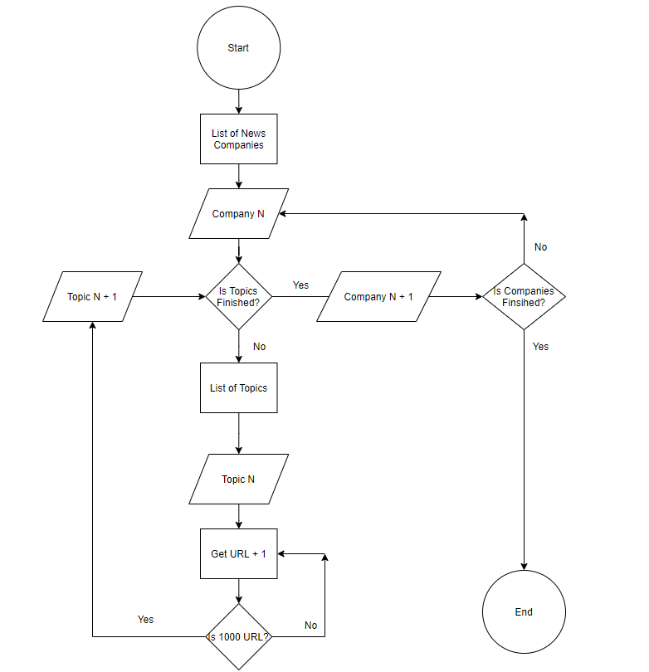

Figure 44 Web Scraper Architecture for URLs

**Article Web Scraper Architecture**

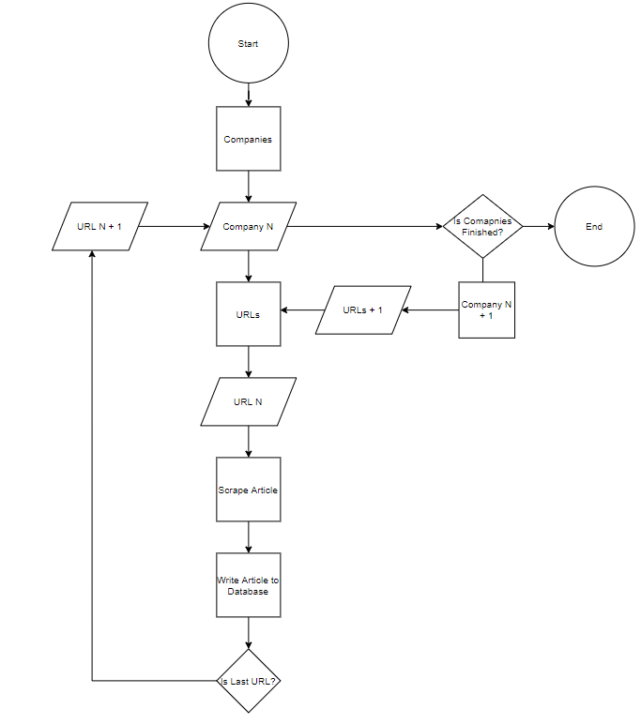

Figure 45 Web Scraper Architecture for Links

## 4.4.2 *Data Cleaning and Building the LDA Topic Model*

The creation of the LDA model depends heavily on process of data cleaning. As discussed within the design chapter, this step is critical, as the higher the quality of data cleaning the more accurate the LDA will become.

Within the implementation, the articles go through a large number of different processes in order to remove unanalysable data. Regex is use to remove new lines, emails, quotes, headers and any other non-meaningful data such as stop words. Bigrams are then created which combine any words that are commonly used together as well as trigrams and four-grams using modelling. Lemmatization is then performed which removes tenses from words in order to have them in their most neutral form.

### Data Cleaning and Building LDA Model Process

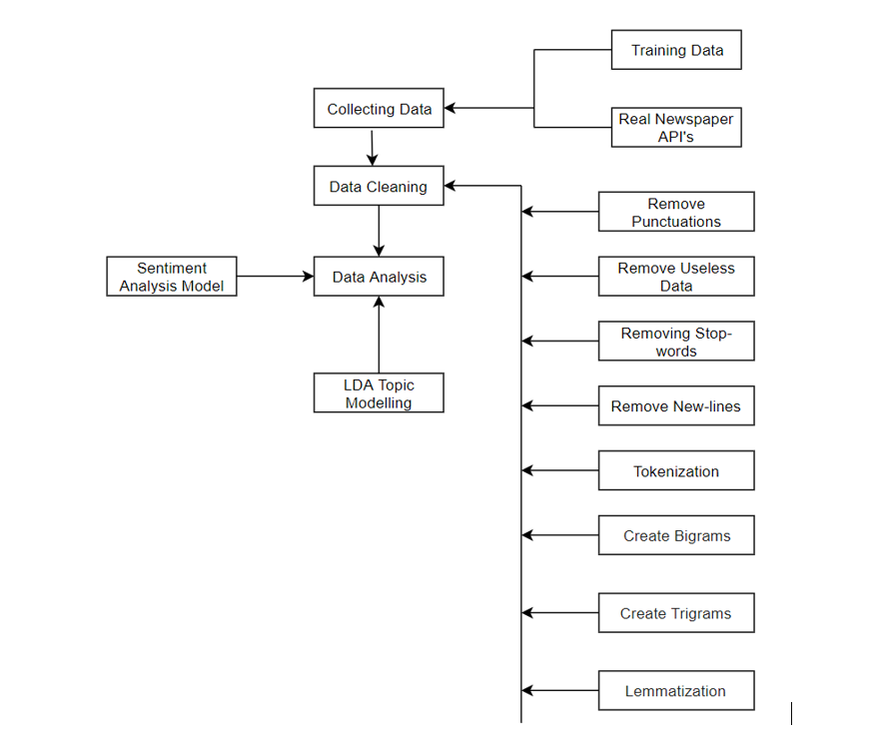

Figure 46 Text Mining and Building LDA Model

Once the data is cleaned, the word corpus and dictionaries are created. The word corpus contains the IDs of words and their frequency and the word dictionary maps IDs to the words. An LDA model is then created with fifty words per topic and a total of N topics in the current instance of the project. The LDA mallet wrapper is introduced to improve accuracy which provides considerable advantages to only using genism’s wrapper and these advantages are further discussed in the evaluation phase.

The number of topics greatly affects the accuracy of the LDA model and this is a topic discussed at length within the area. The quality of data cleaning as well as data size also have spin off effects on the number of topics created. After manual testing and computing the coherence scores based off of multiple topics, it was found that the ideal number of topics was nineteen, providing the highest coherence score from the tested ranges of five to forty.

## 4.4.3 *Mapping Imaginary Topics to Real World Topics*

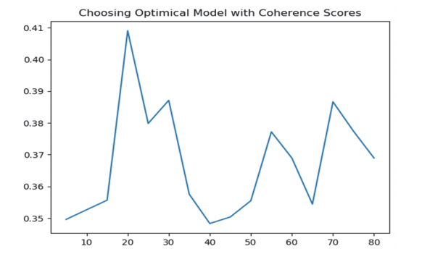

Figure 47 Choosing Optimal Number of Topics [56]

As discussed heavily within the background research and design section the mapping of imaginary topics to real world topic names is an extremely difficult area with no complete solutions at the time of writing this thesis. The final solution that was implemented within this thesis is a novel one that attempts to map the distance from the most heavily weighted words within an imaginary topic to their most likely topic using a probabilistic method.

Initially multiple approaches were taken to attempt to solve this issue. The first solution was to find the hypernym of the top weighted words and use the result to represent the topic. The hypernym is a word that constitutes a category into which more specific words fall into. As an example, color is a hypernym of red. This attempt failed as the top weighted words may not always be referring to the same topic. An example is the top weighted words of Trump, Campaign and Impeachment. If a hypernym was calculated between these three words it would not result in an accurate category that represents these words.

Another attempt implemented searching Wikipedia with the top weighted terms and using the results to dictate the more general meaning of the topics. This attempt while accurate in some instances also fell short and returned negative results. In the previous example of Trump, this method would have worked, but in the example of basketball where the top words are “win”, “lose”, “team” this automatic real name topic discovery system would be faulty in this instance.

The novel approach implemented within this project is as follows. A word dictionary uses each word within the articles as a new key. Each word within the dictionary points to an array that contains the topic name where the article was found when scraping for the word, the original sentence, the URL the word is from, the name of the author that wrote the word and the date the article containing the word was published. The design of the dictionary can be seen below.

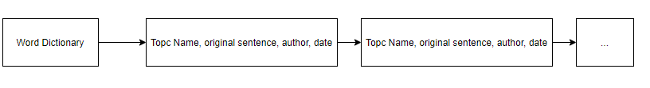

Figure 48 Topic Word Dictionary Mapping

Once this word dictionary is generated, the most weighted words from each imaginary topic are checked against this dictionary and where the topic name appears the most within this check is the real name of the topic until the topic dominance fight begins.

The dominance fight (Implemented inside the “topic_fight” method) is used to compare between two topics which are competing for a topic name that share similar attributes. As an example, the imaginary topic that is actually China may receive the real topic name business due to the similar words associated with the topic of business (Tariff, global, economy, cost), but when the topic that represents business is assigned a name, the business topic is already being used by China. This method to fight topics makes both topics compete to see which topic has more similar words and have the right to the topic name of business, where the loser is re-evaluated again and can find its correct topic name now that business is excluded from the topic’s options.

This method requires knowing what topics are being searched for beforehand, but provides a very accurate mapping of imaginary topics to real name topics. The only issue encountered is that very generic topics cannot be mapped to a real name counterpart and this is a problem that where it is difficult to find a perfect solution as there is not one answer that can fit every generic topic. As an example, even a person may struggle to label the topic of the words “birth, woman, health, choice” which can refer to the topic of pregnancy, child birth or even abortion but it can be very difficult to automatically and assertively map a specific topic without prior context. The meaning of a topic like this can also have different meanings to different people as complete objectivity is not easy to maintain. For these words the LDA topic model mapped abortion as the topic name and this was indicative of the scraped articles.

## 4.4.4 *Mapping Topic Words to Original Sentences*

Mapping of the words from the topic model to their original sentences is crucial as the sentiment analysis model must be applied on the full sentences rather the single words it returns. The problem is that the LDA topic model splits each word individually from its sentences in order for the model to calculate and map to which topic the words are generally referring towards. For the purposes of mapping of words to their original sentences, the probabilistic method discussed above is used due to its high accuracy.

Once the topic names are calculated, the word corpus can be looped through again and now only the sentences of words that map to a particular topic name are returned. This is very efficient since every single sentence will naturally belong to this topic and sentiment analysis can be ran in isolation for each topic, regardless of the order of sentences.



Figure 49 Topic Word Dictionary Mapping

## 4.4.5 *Drawing more Information from the Results and Improving Graph Representation*

After analysing the topic sentiment results for the news organisations, many sentiments for both the Daily Mail and the Independent managed to remain close to neutral without showing a strong stance with the exception of a few topics such as drugs and Brexit.

Graphs of the mode were introduced as the average can infer the general representation of a topic, but due to outliers it may skew the data inconsistently. The mode on the other hand will display how the topic was most consistently represented, regardless of outliers.

The addition of the mode showed that most sentences were generally neutral, but after further examination many sentences were far from objective with very positive and very negative statements read in the output. This seemed to be as a result of the many sentences being neutral such as “The Bishop left the building” which would return a sentiment score of zero and skew the results accuracy due to the large amount of bland sentiments, but a few select statements would encompass the real sentiment such as “The Bishop showed a tremendous display of courage”. In order to improve the results in this instance, results that returned zero were eliminated, to be able to receive a more accurate representation of the results.

## 4.4.*6 Improving the Quality of Topics*

Various challenges were encountered within the development process that were initially not planned for within the design phase. Initially the model computed a very low coherence and perplexity score meaning that the quality of topics was very low and a number of different actions to improve these scores were taken. Firstly, a more powerful, exhaustive data cleaning algorithm was introduced to remove irrelevant data. Data cleaning methods introduced include, creating bigrams which combine two words that are commonly used together into one word and removing all special symbols, emails using powerful regex expressions. The data size for building the model was also increased to over seven thousand in order to further increase the accuracy of the model. Modifying the number of topics created (discussed in more detail within the evaluation chapter) and adding a new LDA mallet wrapper were also employed to further increase accuracy.

Another issue that was encountered was the time it takes to create a model. For a relatively small data set of 7000 articles the LDA model, as well as data cleaning took over 20 minutes for completion. In order to increase the efficiency different libraries were looked into that were more optimised for natural language processing. The library that was previously discussed within the background research phase was SpaCy which has a large portion of its functionality implemented in the C programming language. The library that was used prior was exclusively Scikit-learn which had a slower implementation of the data cleaning algorithms since it is completely implemented within the python language. Certain regex expressions were also further simplified and less exhaustive approaches to remove all useless characters were created.

## 4.4.*7 Overview of Key Code*

The overview of the code has been added to the **appendix section** due to the large amount of code involved and discussed. Within this section a quick overview of the code involved will be presented and if more detail is required it can be found within **Appendix A**. Note that only the main files are discussed in order to maintain clarity and helper files which are responsible for re-formatting articles and output are not noted below.

The main code files discussed are:

1. Scrape_articles.py
2. Generate_lda.py
3. Visualize_lda.py

The file “scrape_articles.py” is responsible for scraping URL’s and articles from any specified company once the REST standards for that website are known. In order to save time and scrape articles much faster, the application is multithreaded and sets up a daemon system that splits the job of scraping articles into separate tasks.

The “generate_lda.py” file is responsible for data cleaning, creating the word corpus and dictionary and creating the base LDA model. It is also responsible for creating a separate word corpus which maps every word to its original respective sentence, author, date it was published, and URL for traceability.

The “visualise_lda.py” file is responsible for the visualising the created topics, testing the quality of the topics created using perplexity and coherence scores, improving the LDA model using a new wrapper, mapping the LDA topic model to the sentiment model, as well as implementing a novel algorithm to map the imaginary topic names to their real counterparts.

## 4.5. Backend

The backend is only included as a means to send the results of the news outlets sentiments to the front-end as a native data source to Grafana and as a result is not an area of complexity within this project. Below, the table created encapsulates the information for a news company in the table named ‘topic’.’sentiments’. The backend is using a simple MySQL server with select permissions enabled for a created Grafana user that will access this data.

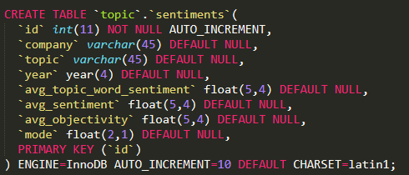

Figure 50 MySQL Sentiment Table

# 5. Testing and Evaluation

## 5.1. Introduction

This chapter will discuss the methods for testing and evaluating the project that were discussed in the previous sections including the model’s accuracy and the steps were taken to ensure code validity. This testing was performed through a variety of automated tests such as unit tests, user evaluation performed through surveys, testing models on unseen data where the result is already known and integrated tests.

## 5.2. System Testing

The project was tested iteratively throughout the development process. Each feature that was introduced was first prototyped to quickly introduce the new feature at a basic level and it was then continuously improved through each iteration. The advantage of using prototypes was that it reduced the time it took to implement all of the required pieces of functionality as it allowed for an adaption to change as the development process progressed. Prototyping allows the simulation of important aspects, unveiling the previously not-fully appreciated design issues [37].

The spiral model requires user feedback and as a result user testing was also integrated throughout the iterative stages. This was performed through random participant surveys. The survey questions will be created by the model’s predications and the user’s ability will be compared to that of the model’s ability. This will ensure that accuracy is not lost as new features are introduced and the existing features are integrated and updated.

## 5.2.1 *Unit Tests*

Unit-tests were performed in order to ensure that individual units of the software such as methods are well tested and account for edge cases. Unit testing is the first level of software integration and ensures that as new code is introduced, each prior unit does not break in terms of functionality. Unit tests also act as documentation that explains what the code is performing at various stages.

Below the performance of the unit tests as well as a small subset of the unit tests can be seen in the following figures.



Figure 51 Unit Tests Execution

The below unit tests test the output of the sentiment retrieval method, the retrieval of the word corpus and the calculation of the median and mode. These tests ensure that output is as expected in different scenarios. In the second last test “test_calculate_sentiment_mode” an edge case was caught that was not previously known and that returned errors at what seemed like random intervals when the mode was calculated for sentiment. The error was that if multiple modes were calculated, it returned the entire list rather then a single float value. This test caught the error instantly and shows the value of unit testing, as an appropriate fix was then applied.

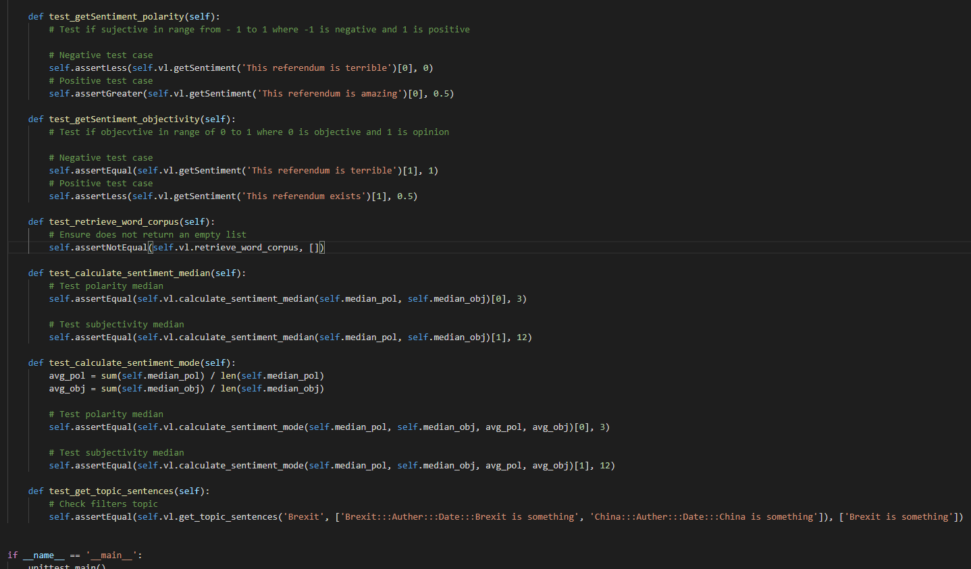

Figure 52 Unit Tests Code

## 5.2.2 *Integration tests*

Integration testing is the next level of testing that checks multiple components within the software at the same time. While unit tests are useful to ensure different sections of code work well in isolation, integration takes this a step further and adds another level of integrity that ensures the software works correctly. This type of testing requires acting like a user of the application through actions such as:

* Calling a HTTP REST API
* Calling a Python API
* Calling a web service
* Running a command line

These integration tests can be run in the same way that unit tests are written, following an input, execution and assertion pattern. The significant differences is that the integration tests are checking multiple components at once such as a network socket or if an API is reachable.

were also performed where multiple units are combined in order to expose faults within the interaction of units. Big bang or top down testing were considered in order to combine all of the units and test them appropriately.

The integration tests below show that the news company websites are reachable, as well as ensure the correct version of python is installed, as well as java (which is required for creating the LDA model).

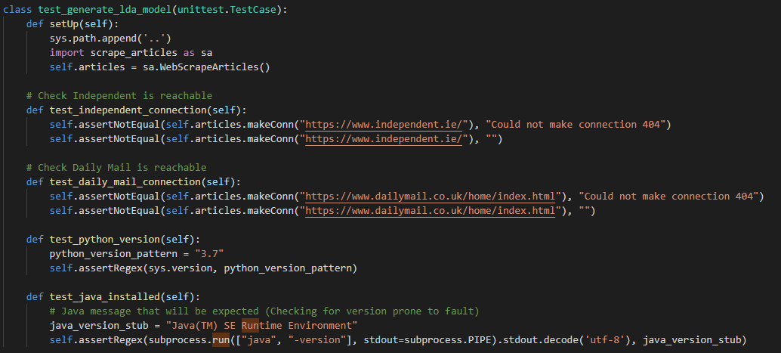

Figure 53 Integration Testing Code

## 5.2.3 *System testing*

System testing was found to lack a strong application within this system. System testing is a form of black-box testing and requires testing requirements such as the environment setup, monitoring usability, security and documentation. The environment has already been tested with integration tests and the usability is only performed through display graphs. Security and documentation are also safely performed due to the lack of user interaction and the clear documentation provided.

## 5.2.4 *Acceptance Testing*

The last stage within testing is acceptance testing. This stage is also implemented within Grey-Box testing and ensures that the required functionality is fully implemented and working as expected. This form of testing is performed through such actions as beta testing a product by the end user. In this instance, the acceptance testing will be performed through the user surveys that are discussed within the next section which will analyse the accuracy of the LDA and sentiment model. As the system has no direct user interaction, the use of survey to determine the accuracy of data performs the same functionality as beta users testing the product, as the product in this instance is the data returned.

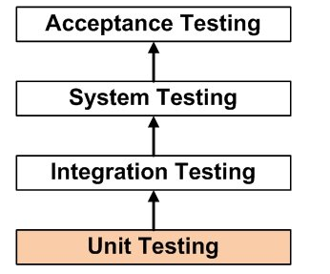

Figure 54 Stages of Integration Testing [41]

## 5.2.5 Grey-Box Testing

Grey-Box testing was integrated in order to ensure that both the internal logic and paths of execution, requirements and functionality are successfully tested. Grey-box testing combines both White-Box and Black-Box testing. It is a more advanced form of testing that aggregates both methods in order to provide a different angle of testing to ensure that different paths of execution work as expected (from White-Box testing) and find errors in performance, incorrect functions, initializations and more (from Black-Box testing). The aim of Grey-Box testing is to verify system implementations against its specification. [38]

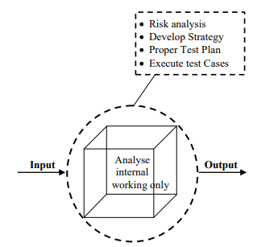

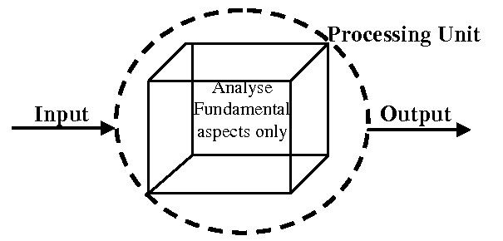

Figure 55 White-Box Testing [39] Figure 56 Black-Box Testing [39]

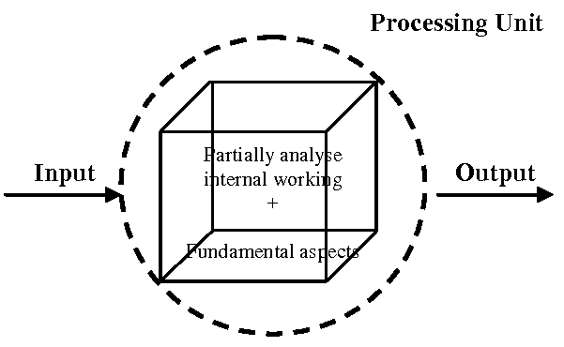

Figure 57 Grey-Box Testing [39]

As can be seen from the above diagrams Grey-Box testing encapsulated both the internal working analysis from White-Box analysis and functional aspects of Black-Box testing.

GitHub is used as version control to ensure that any changes that reduce accuracy can be easily rolled back. GitHub also acts as a failsafe in the scenario where sections of the project may be deleted.

## 5.3. System Evaluation

The evaluation of the system is equally as important as the testing phase. Multiple methods of evaluating the system have been investigated and the solutions have been explicitly varied in their approach in order to ensure that the data created is meaningful and has a strong degree of accuracy.

The first method of evaluation requires random participates to fill out a questionnaire where they try to map the given words to a topic that the LDA algorithm created and see if they arrived at the same conclusion as the model. The same would be done for the sentiment scores where human sentiment detection would be compared to the models.

A survey would present a list of the words connected to a topic and the participant must guess the topic using the words presented. The participant can then infer that the topic is hospitals using words such as (patient, cancer, process, late) and so on. If a high accuracy between human topic matching and automatic topic matching is created then it stands to reason that the topic modelling approach is accurate. This approach would also be copied and altered to suit a survey for users guessing the sentiment of sentences and comparing their results to the ones automatically generated.

## 5.3.*1 User Ability to Guess Topics*

A method of evaluation that applies to both the LDA topic model and sentiment model testing is to check the accuracy against a document that has manually computed either sentiment scores or topics. This requires new data for evaluation as training data that the model was created upon cannot be used. Through comparing the manually generated topics names against that of the user an accurate score can be generated around how closely the model resembles a human’s capability of deciphering either sentiment or topic creation.

The below survey below showcases the highest weighted words from the created topics using the LDA topic model. The first list refers to the topic “Abortion” with the words all describing this particular topic. The second list refers to “Brexit”, the third “medicine”, the fourth “Trump” and finally the fifth “Housing”.

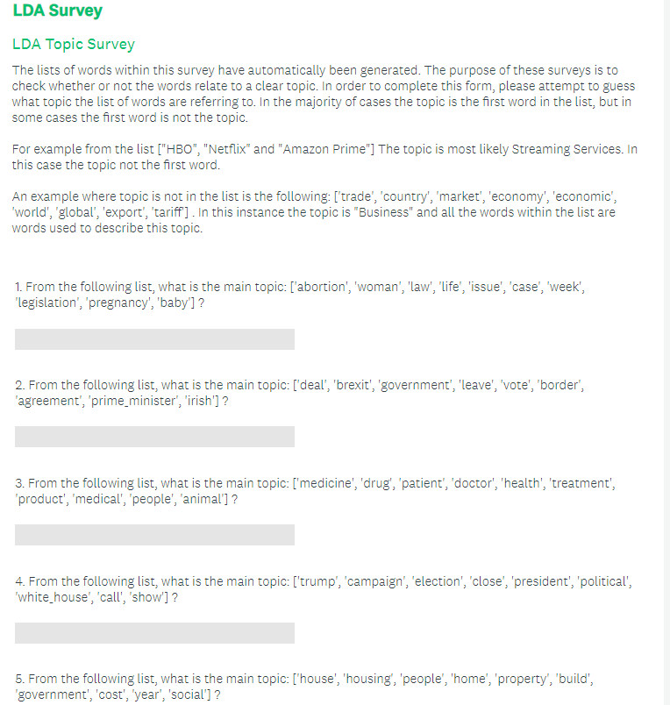

Figure 58 LDA Survey used to Evaluate Model

For testing the quality of the topics, twenty random participants were asked to fill out this survey and the results are as follows.

For the first topic list refereeing to abortion:

* Nine correctly guessed abortion
* Six Guessed Women’s rights
* Three Pro-Life
* One guessed pregnancy
* One guessed life

For the second topic list refereeing to Brexit:

* Thirteen correctly guessed Brexit
* Two guessed Vote
* Two guessed Politics
* One guessed Boris Johnson
* One guessed EU
* One guessed Law

For the third topic list refereeing to Medicine:

* Fourteen correctly guessed medicine or hospital or health
* Three guessed drugs
* Two guessed coronavirus
* One guessed Animal Testing

For the fourth topic list refereeing to Trump:

* Six correctly guessed Trump
* Six guessed election
* Four guessed Election
* Two guessed USA
* One guessed government
* One guessed political

For the fifth topic list refereeing to Housing:

* Nineteen correctly made a reference to the housing epidemic
* One guessed real-estate

From the above results, the LDA topic model was capable of guessing the correct topic for each sequence of words, whereas the random participants managed to guess 61% correctly with 39 guesses out of 100 being something related to the current topic. The results seem to convey that the LDA topic model is more capable of guessing the topic then a random participant of the public.

## 5.3.*2 Effect of User Bias when understanding Topics and Sentiment*

When conducting any type of research that is subjective, bias always play a role and has the possibility to impact results if not accounted for correctly. In this instance user bias may have skewed the results due to user bias. As an example, within the third topic of medicine, two individuals guessed coronavirus even though there was no mention of the illness, but due to the epidemic that is taking place the guess was altered. This inconsistency could have been avoided through conducting user surveys to first determine any bias that may be present and only after the screening allow certain participants to complete the survey if the chance for bias was deemed low.

## 5.3.*3 Improvements on Perplexity and Coherence Scores*

A method of evaluating the LDA and sentiment topic models is to use probabilistic algorithms that are used to define the accuracy of machine learning models. For LDA two such sores are Perplexity and Coherence scores. Perplexity score is a statistical measure of how well the model predicts a topics relation to the words through comparing word distribution and topic mixtures where the lower the score the better. The coherence score is used for assessing the quality of the learned topics through checking the number of words that appear in multiple topics where the higher the score, the higher the quality of the topic.

Through various improvements and modifications within the creation of the LDA model, the quality of topics was improved over time. Initially with the LDA prototype and a more basic data cleaning algorithm, the coherence score was 0.32 and perplexity was -23.56. After the data cleaning algorithm was revised and improved the coherence score rose to 0.41 and the perplexity rose to -22.84.

Once the training data was changed to real newspaper data, and the number of topics was adjusted to nineteen a higher accuracy was again reached as the coherence score rose to 0.45 and the perplexity lowered to -21.3. The LDA mallet wrapper was then used over the Gensim wrapper and this again improved the coherence score 0.55 and lowered the perplexity to -15.67

## 5.3.*4 Sentiment Evaluation*

The library used to extract sentiment was TextBlob and not an area of major complexity within this project. The main factor which affected the sentiments accuracy within this context was the quality of the data cleaning algorithm which has been discussed in detail within chapter three and four. In order to assess the accuracy of the sentiment analysis performed, sentences were tested against a list of positive sentences found in the file “positive.txt” and a list of negative sentences in the list “negative.txt”. This data set includes a lot of confusing and ambiguous sentences that are difficult even for a human to understand providing a good baseline to test against.

The results showed that the positive results were 76.1% accurate and the negative were 68.6% accurate. Each list included 5225 separate sentences and due to their high amount of difficulty the sentiment evaluation seems to be very capable to manage analysing the sentiment within newspaper articles, where more clear language is used.

The below survey was provided to twenty users and the sentences were picked from the positive / negative sentences dataset used to train the model above. The survey found that 76 out of 100 questions were answered correctly. The positive results model show case an equal accuracy as the twenty random participants and the negative score accuracy is only slightly smaller showing that the model is almost as capable as an individual to guess the sentiment of a sentence.

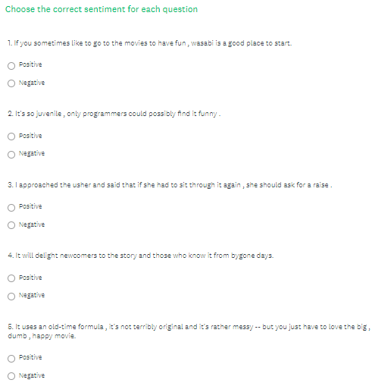

Figure 59 Sentiment User Survey

## 5.3.*5 Automatic Stance Detection Scoring Analysis and Baseline*

Understanding the results and creating a baseline for a negative, positive and neutral representation of a topic is a challenging area. The average result for how a topic is most represented is not always a strong indication of how a topic is perceived as many sentences that discuss this topic can be neutral and only a few select sentences can show case the true representation of a topic.

In the figure below “Independent Mode Sentiment” the mode provides a clearer outline of how topics are represented when the zero values that skew the results to zero are removed as can be seen when compared to the following figure “Independent Average Sentiment”. An example is the topic of sports. Due the large number of neutral sentences, the average sentiment value is 0.11, but the mode sentiment value is 0.7, showing a large amount of positive reactions. Similarly, many sentiment averages pertain results that hang at 0.1 or lower, whereas the mode results are much more reflective with a larger range of values that are more evenly dispersed. Following that the mode is a better representation of media sentiment or stance, it seems that the mode should be the underlying representation of the sentiment and not the average.

Through analysing the descriptive words of the media, it was found that it is rare for a public news media to use very positive terms such as “amazing” or terrific” due to their informality in comparison with the large amount of negative words such as “destructive” or “outrageous”. This seems to point to a points system that is skewed in a more negative direction, and this should possibly lower the expectation for positive language to negative language.

Using the system described above, it stands to reason that a possible approach is if the result is zero the sentiment is negative, any result that falls between 0.1 and 0.3 is neutral and anything above is positive. This is particularly true as it is rare for the news media to use very



Figure 60 Independent Mode Sentiment



Figure 61 Independent Average Sentiment

## 5.4. Conclusions

This chapter examined both the methods of testing and evaluations of the presented system. The testing section discussed the testing methodologies that were integrated such as unit testing and Grey-Box testing. The evaluation section delved into how to critically test the LDA model’s capability to produce topics and the sentiment model’s ability to understand human sentiment through three alternative methods. The first evaluation is completed through comparing the model’s capability to that of random individuals through random participant surveys. The second computes scores to critically determine that the algorithms model is accurate using probabilistic algorithms. The final method of evaluation uses new data that already has already had sentiment scores and topics generated by an individual and this data is compared to their results.

# 6. Issues and Future Work

## 6.1. Introduction

This chapter introduces the issues and risks within the development of this project and the future applications and improvements that can be implemented. As discussed in detail within the previous chapters, the current system has been shown to accurately implement an LDA topic model that can identify topics, identify and map the real topic names to the imaginary topics, map the original sentences to the LDA topic model, source large amounts of articles pertaining to particular news outlets, topics and date intervals and finally display this information using Grafana.

The literature review has aided in the creation of all of the requirements for this system and better understanding the suite of technologies and approaches available. The design has also encompassed the requirements gathering and the approach to be taken in order to complete this system using a mix of Kanban, simplified spiral modelling and CRISP-DM.

## 6.2. Issues and Risks

The challenges that were resolved in this project are as follows:

* A method of linking the imaginary numbers of topics to real-life topics. [DONE]
* Linking to a real newspaper API that has access to thousands of newspaper articles. [DONE (Using inbuilt web scraper instead of a news API)]
* A method of parsing the json data provided by the API above. [DONE]
* Methods to increase the accuracy of the LDA model. [DONE]
* An increased level of knowledge in order to implement Grey-Box testing. [ON]
* A sentiment analysis algorithm to determine whether or not a sentence is positive, neutral or negative. [DONE] - Aided with third party libraries as complexity is not within the creation of the sentiment model
* A method of mapping each sentiment analysis result to where the topic is flagged. [DONE]
* A user interface that can display topics as well as their sentiment score and link them to specific newspaper companies. [DONE]
* Adding random participants to evaluation and testing phases. [DONE]

The proposal to approach these challenges are as follows (respectively):

* Using automatic probabilistic methods in order to map word-frequency to topics.
* Acquiring an API key from a news source API source such as: <https://newsapi.org/s/ireland-news-api> and writing code to retrieve articles daily. (Limit of 500 a day using above source).
* JSON parser and regex expressions for finding interesting metadata.
* Using different LDA model libraries, increasing data size and distribution of topics, more fine-tuned data processing and more methods to specifically increase model accuracy.
* Research Grey-Boxing projects and Udemy courses on this topic.
* Research how sentiment analysis works implement a suitable model.
* Both models will be computed separately and some pre-processing will be required in order to link them, possibly using the hash maps data structure.
* A user interface can be displayed with a suite of topic modelling libraries such as “matplotlib” and “pyLDAvis” exist for visualisation. The key interface will be accessed through command line which will create various html files for visualising different graphs and components. A textual result in a CSV will also be computed of all newspaper included and their bias score as well as the overall bias score by media.
* Random participants will be included in the development and evaluation process through requesting individuals to perform in a study where they will answer questions within surveys that will dictate how accurate the sentiment and topic models are in assessing the results.

The risks that may occur include are as follows:

* A limit of 500 requests per day using the main news API for Irish newspapers. [AVERTED THROUGH USING DIFFERENT APPROACH FOR SCRAPING ARTICLES]
* Failing to complete the proposed project and all of the core functionality with high accuracy models implemented. [AVERTED THROUGH IMPROVEMENTS]
* Topic Model being too inaccurate to be useful. [AVERTED THROUGH OWN IMPROVEMENTS TO MODEL]

The planned approach to these various risks is as follows:

* Request 500 articles daily. Within 10 days this can amass to 5000 articles which is enough to build an LDA topic model from the real data. [AVERTED THROUGH DIFFERENT APPROACH FOR SCRAPING ARTICLES]
* Using the Kanban method work will be time boxed each week. Progress will be followed by counting the number of Pomodoro points that were completed each week and a consist pace will be maintained in order to keep track of all work. The simplified spiral model will also provide a method to analyse risks before each iteration and aid in their prevention. [DONE]
* An iterative approach will be implemented in order to gradually improve the accuracy of the LDA model and the progress will be monitored seeing the updated coherence, perplexity score and accuracy in terms of user evaluation surveys. [DONE]

## 6.3. Plans and Future Work

Two GANTT charts show how progress has been completed and these two charts can be compared at the end in order to provide the difference between the planned and implemented approach.

A major area of growth within the field of computer science and business is using sentiment analysis to correlate the effects that this has on stock trends. Many consumers rely on influential institutions and celebrities for information about the broad market and depending on the sentiment towards this market and more specifically certain stocks, they can have a strong effect on the growth and decrease of stocks as consumer confidence grows or decreases. The value of such a system could be extremely useful if correlation could accurately be plotted and used to predict the value of stocks within the future

Fake News Detection is a growing area that is strongly correlated with bias detection in news articles. Through identifying the stances that newspaper companies present on a given day, a probability score can be calculated to determine if another piece of external news is fake or not. This score will determine how different the bias scores are too news for that day, while also taking into account what topics are discussed. Many fake news outlets will centralise rumours around specific celebrities or events and if these new pieces of information are not discussed in reputable news companies it may be likely that it is in fact fake news. This can be iterated on as a product as a plugin could in real time analyse an article that is in the browser and compare the results to news similar news during that day.

An area with particular interest that this project brushes off of includes pattern matching correlative trends across strongly related topics. An example of such a correlative trend is where the sentiment for one topic such as climate change improves, sentiment towards the beef industry deteriorates. This project has the potential to expose such tightly linked correlations and assist in a better understanding of how public sentiment affects the real world.

Ethnography is an account of social life and culture in a particular social system based on the actions of people in a particular culture observed. This thesis can be applied in the area as it a comparative scale across different subjective views and can be analysed objectively across different cultures. Examples could be the level of sentiment represented towards religions, government, social movements and any other topic that is discussed in detail. From interviews that can be transcript, to novels and the news media a wide range of sources can be used to obtain this data.

Applying stance analysis to psychoanalysis bring forth a number of ethical barriers that prevent the recording and record keeping of psychiatric sessions in order to maintain a strong level of privacy between doctor and patient. The application seems to specifically extend towards researching on a mass scale the differences in cultural sentiment identified by different groups and better understanding how these belief systems effect various techniques within their application.

### 6.3.1. GANTT Chart

### First GANTT Chart

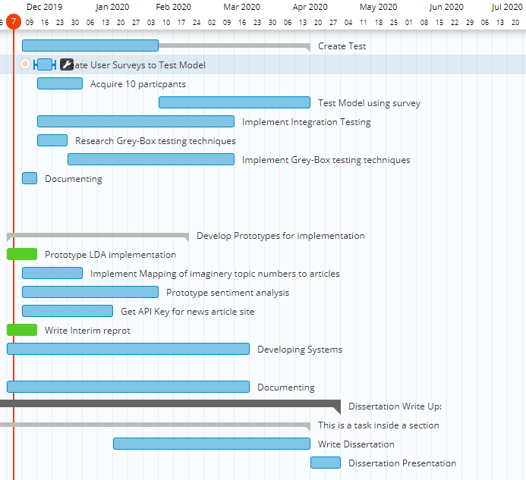

Figure 62 GANTT Chart

### Second GANTT Chart

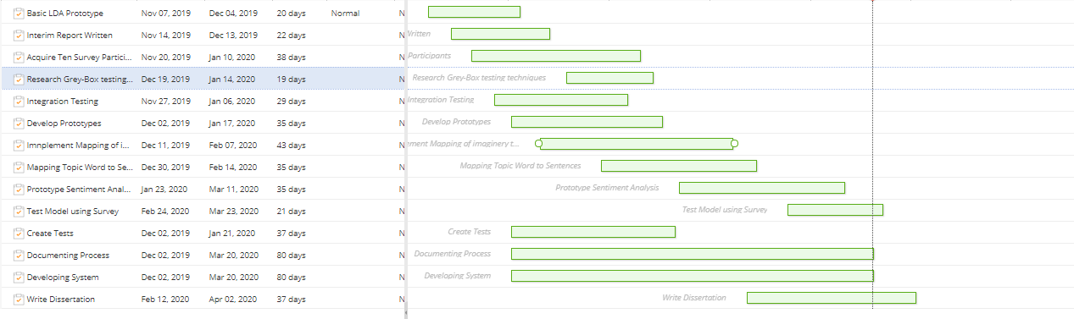

Figure 63 GANTT Chart 2

### 6.3.2. Kanban Board - Final Year Project

Figure 64 Dissertation Kanban Report

# Bibliography

1. 2012/2013 JNRS - Readership [Internet]. News Brands Ireland. 2013 [cited 2019 Dec 1]. Available from: <https://newsbrandsireland.ie/jnrs-20122013/>
2. Mäntylä MV, Graziotin D, Kuutila M. The evolution of sentiment analysis—A review of research topics, venues, and top cited papers. Computer Science Review. 2018 Feb;27:16–32.
3. Blei D. Probabilistic topic models. Communications of the ACM [Internet]. 2019 [cited 4 December 2019];(55):77–84. Available from: <https://dl.acm.org/citation.cfm?id=2133826>
4. Chen J, Yamada Y, Ryoke M, Tang X. Knowledge and systems sciences. 1st ed. Tokyo: Springer Singapore; 2018.
5. Liu Q, Chen Q, Shen J, Wu H, Sun Y, Ming W-K. Data Analysis and Visualization of Newspaper Articles on Thirdhand Smoke: A Topic Modeling Approach. JMIR Med Inform [Internet]. 2019 Jan 29 [cited 2019 Dec 6];7(1). Available from: <https://www.ncbi.nlm.nih.gov/pmc/articles/PMC6371067/>
6. Blei D. Probabilistic topic models. Communications of the ACM (55):77–84. Available from: <https://dl.acm.org/citation.cfm?id=2133826>
7. T.P. A Sentiment Analysis Approach to Predicting Stock Returns [Internet]. Medium. 2018 [cited 2019 Dec 4]. Available from: <https://medium.com/@tomyuz/a-sentiment-analysis-approach-to-predicting-stock-returns-d5ca8b75a42>
8. Ganegedara T. Intuitive Guide to Latent Dirichlet Allocation [Internet]. Medium. 2019 [cited 2019 Dec 8]. Available from: <https://towardsdatascience.com/light-on-math-machine-learning-intuitive-guide-to-latent-dirichlet-allocation-437c81220158>
9. Margaret E. Roberts, Brandon M. Stewart, and Dustin Tingley. Navigating the local modes of big data: The case of topic models. In R. Michael Alvarez, editor, Data Science for Politics, Policy and Government. In Press
10. David Hall, Daniel Jurafsky, and Christopher D Manning. Studying the history of ideas using topic models. In EMNLP, pages 363–371, 2008.
11. Godbole N, Srinivasaiah M, Skiena S. Large-Scale Sentiment Analysis for News and Blogs. In 2007.
12. Recasens M, Danescu-Niculescu-Mizil C, Jurafsky D. Linguistic Models for Analyzing and Detecting Biased Language. In: Proceedings of the 51st Annual Meeting of the Association for Computational Linguistics (Volume 1: Long Papers) [Internet]. Sofia, Bulgaria: Association for Computational Linguistics; 2013 [cited 2019 Dec 6]. p. 1650–1659. Available from: <https://www.aclweb.org/anthology/P13-1162>
13. Hamborg F, Donnay K, Gipp B. Automated identification of media bias in news articles: an interdisciplinary literature review. Int J Digit Libr. 2019 Dec 1;20(4):391–415.
14. Gruenewald J, Pizarro J, Chermak SM. Race, gender, and the newsworthiness of homicide incidents. Journal of Criminal Justice. 2009 May 1;37(3):262–72.
15. Oliver PE, Maney GM. Political Processes and Local Newspaper Coverage of Protest Events: From Selection Bias to Triadic Interactions. American Journal of Sociology. 2000 Sep 1;106(2):463–505.
16. Patankar A, Bose J, Khanna H. A Bias Aware News Recommendation System. In: 2019 IEEE 13th International Conference on Semantic Computing (ICSC) [Internet]. Newport Beach, CA, USA: IEEE; 2019 [cited 2019 Dec 7]. p. 232–8. Available from: <https://ieeexplore.ieee.org/document/8665610/>
17. Elyashar A, Bendahan J, Puzis R. Is the News Deceptive? Fake News Detection Using Topic Authenticity. In 2017.
18. Loper E, Bird S. NLTK: The Natural Language Toolkit. CoRR. 2002 Jul 7;cs.CL/0205028.
19. Dutt R, Hiware K, Ghosh A, Bhaskaran R. SAVITR: A System for Real-time Location Extraction from Microblogs during Emergencies. arXiv:180107757 [cs] [Internet]. 2018 Nov 19 [cited 2019 Dec 5]; Available from: <http://arxiv.org/abs/1801.07757>
20. Natural Language Processing for Beginners: Using TextBlob [Internet]. Analytics Vidhya. 2018 [cited 2019 Dec 5]. Available from: <https://www.analyticsvidhya.com/blog/2018/02/natural-language-processing-for-beginners-using-textblob/>
21. scikit-learn: machine learning in Python — scikit-learn 0.22 documentation [Internet]. [cited 2019 Dec 5]. Available from: <https://scikit-learn.org/stable/>
22. Labs DD. Modern Methods for Sentiment Analysis [Internet]. Medium. 2017 [cited 2019 Dec 5]. Available from: <https://medium.com/district-data-labs/modern-methods-for-sentiment-analysis-694eaf725244>
23. WordNet | A Lexical Database for English [Internet]. [cited 2019 Dec 5]. Available from: <https://wordnet.princeton.edu/>
24. Documentation [Internet]. News API. [cited 2019 Dec 5]. Available from: <https://newsapi.org>
25. Punch KF. Introduction to Social Research: Quantitative and Qualitative Approaches. SAGE; 2005. 342 p.4
26. aneeshabakharia. Algorithms for the thematic analysis of twitter datasets [Internet]. Education presented at; 06:19:41 UTC [cited 2019 Dec 5]. Available from: <https://www.slideshare.net/aneeshabakharia/algorithms-for-the-thematic-analysis-of-twitter-datasets2>
27. Antezana L, Lagos C, Cabalin C. La opacidad de la política en la prensa chilena: un análisis de suplementos semanales. Estudios sobre el Mensaje Periodístico. 2017 Nov 20;23(2):727–46.
28. Mortensen D. How to Do a Thematic Analysis of User Interviews [Internet]. The Interaction Design Foundation. [cited 2019 Dec 5]. Available from: <https://www.interaction-design.org/literature/article/how-to-do-a-thematic-analysis-of-user-interviews>
29. Experience WL in R-BU. How to Analyze Qualitative Data from UX Research: Thematic Analysis [Internet]. Nielsen Norman Group. [cited 2019 Dec 5]. Available from: <https://www.nngroup.com/articles/thematic-analysis/>
30. Andrew Powell-Morse. Extreme Programming: What Is It And How Do You Use It? [Internet]. Airbrake Blog. 2017 [cited 2019 Dec 2]. Available from: <https://airbrake.io/blog/sdlc/extreme-programming>
31. What is a Kanban Board? Why and When to Use Kanban? [Internet]. Productivity Land. 2019 [cited 2019 Dec 5]. Available from: <https://productivityland.com/what-is-kanban-board/>.
32. Boehm B. Spiral Development: Experience, Principles, and Refinements [Internet]. 1st ed. 2000 [cited 2 December 2019]. Available from: <https://resources.sei.cmu.edu/asset_files/SpecialReport/2000_003_001_13655.pdf>
33. Chuang J, Wilkerson J, Weiss R, Tingley D, Stewart B, Roberts M, et al. Computer-Assisted Content Analysis: Topic Models for Exploring Multiple Subjective Interpretations. 2014.
34. Liu Q, Chen Q, Shen J, Wu H, Sun Y, Ming W-K. Data Analysis and Visualization of Newspaper Articles on Thirdhand Smoke: A Topic Modeling Approach. JMIR Med Inform [Internet]. 2019 Jan 29 [cited 2019 Dec 1];7(1). Available from: <https://www.ncbi.nlm.nih.gov/pmc/articles/PMC6371067/>
35. admin. What is spiral model?7 Advantages and Disadvantages of model [Internet]. Am7s. 2019 [cited 2019 Dec 2]. Available from: <https://www.am7s.com/spiral-model/>
36. Ambler S. Feature Driven Development (FDD) and Agile Modeling [Internet]. Agilemodeling.com. 2019 [cited 2 December 2019]. Available from: <http://agilemodeling.com/essays/fdd.htm>
37. Buchenau M, Suri JF. Experience prototyping. InProceedings of the 3rd conference on Designing interactive systems: processes, practices, methods, and techniques 2000 Aug 1 (pp. 424-433). ACM.
38. De Nicola G, di Tommaso P, Rosaria E, Francesco F, Pietro M, Antonio O. A Grey-Box Approach to the Functional Testing of Complex Automatic Train Protection Systems. In: Dal Cin M, Kaâniche M, Pataricza A, editors. Dependable Computing - EDCC 5. Berlin, Heidelberg: Springer; 2005. p. 305–17. (Lecture Notes in Computer Science).
39. Khan ME, Khan F. A Comparative Study of White Box, Black Box and Grey Box Testing Techniques. In 2012.
40. Kim S-M, Hovy E. Determining the sentiment of opinions. In: Proceedings of the 20th international conference on Computational Linguistics  - COLING ’04 [Internet]. Geneva, Switzerland: Association for Computational Linguistics; 2004 [cited 2019 Dec 7]. p. 1367-es. Available from: <http://portal.acm.org/citation.cfm?doid=1220355.1220555>
41. Unit Testing [Internet]. Software Testing Fundamentals. 2011 [cited 2019 Dec 7]. Available from: <http://softwaretestingfundamentals.com/unit-testing/>
42. Janson M, Smith L. Prototyping for Systems Development: A Critical Appraisal. MIS Quarterly. 1985;9(4):305.
43. Wirth R. CRISP-DM: Towards a standard process model for data mining. In: Proceedings of the Fourth International Conference on the Practical Application of Knowledge Discovery and Data Mining. 2000. p. 29–39.
44. What is the CRISP-DM methodology? [Internet]. Smart Vision - Europe. [cited 2019 Dec 9]. Available from: <https://www.sv-europe.com/crisp-dm-methodology/>
45. Sentiment Analysis [Internet]. MonkeyLearn. 2018 [cited 2020 Mar 8]. Available from: <https://monkeylearn.com/sentiment-analysis>
46. Nasukawa T, Yi J. Capturing Favourability Using Natural Language Processing. 2003. p. 76
47. Kwiatkowski S. Machine Learning as a Service: Part 1 [Internet]. Medium. 2018 [cited 2020 Mar 9]. Available from: <https://towardsdatascience.com/machine-learning-as-a-service-487e930265b2>
48. Gonçalves P, Araújo M, Benevenuto F, Cha M. Comparing and combining sentiment analysis methods. Proceedings of the first ACM conference on Online social networks - COSN '13. 2013;.
49. Lau JH, Grieser K, Newman D, Baldwin T. Automatic labelling of topic models. In: Proceedings of the 49th Annual Meeting of the Association for Computational Linguistics: Human Language Technologies - Volume 1. Portland, Oregon: Association for Computational Linguistics; 2011. p. 1536–1545. (HLT ’11).
50. Cano Basave AE, He Y, Xu R. Automatic Labelling of Topic Models Learned from Twitter by Summarisation. In: Proceedings of the 52nd Annual Meeting of the Association for Computational Linguistics (Volume 2: Short Papers) [Internet]. Baltimore, Maryland: Association for Computational Linguistics; 2014 [cited 2020 Mar 9]. p. 618–624. Available from: <https://www.aclweb.org/anthology/P14-2101>
51. Mei Q, Ling X, Wondra M, Su H, Zhai C. Topic sentiment mixture: modeling facets and opinions in weblogs. In: Proceedings of the 16th international conference on World Wide Web  - WWW ’07 [Internet]. Banff, Alberta, Canada: ACM Press; 2007 [cited 2020 Mar 9]. p. 171. Available from: <http://portal.acm.org/citation.cfm?doid=1242572.1242596>
52. 1.
53. Kou W, Li F, Baldwin T. Automatic Labelling of Topic Models Using Word Vectors and Letter Trigram Vectors. In: Zuccon G, Geva S, Joho H, Scholer F, Sun A, Zhang P, editors. Information Retrieval Technology. Cham: Springer International Publishing; 2015. p. 253–64. (Lecture Notes in Computer Science).
54. Bhatia S, Lau1 J, Baldwin2 T. Automatic Labelling of Topics with Neural Embeddings [Internet]. Arxiv.org. 2016 [cited 9 March 2020]. Available from: <https://arxiv.org/pdf/1612.05340.pdf>
55. Visualize Time-Series Data with Open Source Grafana and InfluxDB [Internet]. The New Stack. 2017 [cited 2020 Mar 17]. Available from: <https://thenewstack.io/visualize-time-series-data-open-source-grafana-influxdata/>
56. Wahyudin I, Tosida ET, Andria F. Data Science dan Big Data.
57. 1. Augenstein I, Rocktaschel T, Vlachos A, Bontcheva K. Stance Detection with Bidirectional Conditional Encoding [Internet]. 2nd ed. London: arXiv; 2016 [cited 24 March 2020]. Available from: <https://arxiv.org/pdf/1606.05464.pdf>
58. Binkley D, Heinz D, Lawrie D, Overfelt J. Understanding LDA in source code analysis. In: Proceedings of the 22nd International Conference on Program Comprehension [Internet]. Hyderabad, India: Association for Computing Machinery; 2014 [cited 2020 Mar 24]. p. 26–36. (ICPC 2014). Available from: <https://doi.org/10.1145/2597008.2597150>
59. Blei D. Probabilistic topic models. Communications of the ACM (55):83–84. Available from: https://dl.acm.org/citation.cfm?id=2133826
60. Lau JH, Grieser K, Newman D, Baldwin T. Automatic labelling of topic models. In: Proceedings of the 49th Annual Meeting of the Association for Computational Linguistics: Human Language Technologies - Volume 1. Portland, Oregon: Association for Computational Linguistics; 2011. p. 1536–1545. (HLT ’11).
61. Jacobi C, Atteveldt W van, Welbers K. Quantitative analysis of large amounts of journalistic texts using topic modelling. Digital Journalism. 2016 Jan 2;4(1):89–106.
62. C hang, Jonathan, Sean Gerrish, Chong Wang, Jordan Boyd-Graber, and David M. Blei. 2009. “Reading Tea Leaves: How Humans Interpret Topic Models.” InAdvances in Neural Information Processing Systems, 288–296.
63. Pang B, Lee L. Opinion Mining and Sentiment Analysis. INR. 2008 Jul 7;2(1–2):1–135.
64. Wilson T, Wiebe J, Hoffmann P. Recognizing Contextual Polarity in Phrase-Level Sentiment Analysis. In: Proceedings of Human Language Technology Conference and Conference on Empirical Methods in Natural Language Processing [Internet]. Vancouver, British Columbia, Canada: Association for Computational Linguistics; 2005 [cited 2020 Mar 24]. p. 347–354. Available from: <https://www.aclweb.org/anthology/H05-1044>
65. Asghar MZ, Khan A, Ahmad S, Qasim M, Khan IA. Lexicon-enhanced sentiment analysis framework using rule-based classification scheme. PLoS One [Internet]. 2017 Feb 23 [cited 2020 Mar 24];12(2). Available from: <https://www.ncbi.nlm.nih.gov/pmc/articles/PMC5322980/>
66. Severyn A, Moschitti A. Twitter Sentiment Analysis with Deep Convolutional Neural Networks. In: Proceedings of the 38th International ACM SIGIR Conference on Research and Development in Information Retrieval [Internet]. Santiago, Chile: Association for Computing Machinery; 2015 [cited 2020 Mar 24]. p. 959–962. (SIGIR ’15). Available from: <https://doi.org/10.1145/2766462.2767830>
67. Lin C, He Y. Joint sentiment/topic model for sentiment analysis. In: Proceedings of the 18th ACM conference on Information and knowledge management. Hong Kong, China: Association for Computing Machinery; 2009 [cited 2020 Mar 24]. p. 375–384. (CIKM ’09). Available from: https://doi.org/10.1145/1645953.1646003

# Appendix

## Appendix A

### Screape_articles.py:

The multi-threaded web scraper provides the functionality to scrape URL’s and links from news outlets using REST API’s. All code follows a separation of concerns in order to ensure that it is requires no extra work to scrape new news outlets once the URL is provided and the REST standards upheld by the news company are known. This includes how many pages per result are provided and in what tags encompass the title and paragraphs of the article. Below only a few select methods are shown.

def buildArticles(self, company_tag):

        for topic in self.refined_news_categories:

            if '.' in topic:

                topic = ' '.join(topic.split('.'))

            self.pull_articles(topic, company_tag)

            self.q = Queue()

            self.run = True

    # Using threads pull articles

    def pull_articles(self, topic, tag=None):

        NUM_THREADS = 2

        self.call_tag = tag

        # Get all links in an object

        if self.call_tag == self.independent_tag:

            links = self.getCorpusLinks(self.independent_tag, topic)

        elif self.call_tag == self.daily_mail_tag:

            links = self.getCorpusLinks(self.daily_mail_tag, topic)

        elif self.call_tag == self.irish_times_tag:

            links = self.getCorpusLinks(self.irish_times_tag, topic)

        elif self.call_tag == self.new_york_times_tag:

            links = self.getCorpusLinks(self.new_york_times_tag, topic)

        for _ in range(NUM_THREADS):

            # Create the new thread using threader method

            t = threading.Thread(target = self.pull_articles_threader)

            t.daemon = True

            # Start the thread

            t.start()

        for link in links:

            self.q.put(link)

        self.q.join()

        self.run = False

    def getDailyMailArticle(self, urlTopic):

        url, topic = urlTopic.split('|')

        article = ''

         # Header holds the date of article, url and author

        header = ''

        try:

            response = requests.get(url) # , headers=ua)

            soup = BeautifulSoup(response.text, 'lxml')

            # Get the author

            author = soup.find('p',attrs={'class':'author-section byline-plain'})

            # Get the date of the article

            date = soup.find('span',attrs='article-timestamp article-timestamp-published')

            header = '{ ' + author.text + ' ' + date.text + ' ' + url + ' }' + '\n'

            # Get the paragraphs of the article

            articleDivs = soup.find('div', attrs={'itemprop':'articleBody'})

            paras = articleDivs.findAll('p', attrs={'class':'mol-para-with-font'})

            for para in paras:

                article += ''.join(para.findAll(text=True)) + ' '

            if article == '':

                paras = articleDivs.findAll('p')

                for para in paras:

                    article += ''.join(para.findAll(text=True)) + ' '

            with self.lock:

                # Write articles to corpus

                self.write_to_file(header + article, self.daily_mail_tag, topic)

        except AttributeError:

            print('Failed to find what we looked for at link, ' + url)

            # When failed to read file, IP blocked,

            # send file to other dir and can read it later

            self.write_dead_file_to_dir(url, self.daily_mail_tag)

            print('Sleeping to stop IP block...')

            time.sleep(20)

        except UnicodeEncodeError:

            print('UniCodeEncodeError occured at link' + url)

        return url

The generate_lda code below is one of the LDA topic models that was implemented.

### generate_lda.py:

def gen_bunch(news_path):

    # Cateogies in data set

    news_categories = ['alt.atheism', 'comp.graphics', 'comp.os.ms-windows.misc'

                , 'comp.sys.ibm.pc.hardware', 'comp.sys.mac.hardware', 'comp.windows.x'

                , 'misc.forsale', 'rec.autos', 'rec.motorcycles', 'rec.sport.baseball'

                , 'rec.sport.hockey', 'sci.crypt', 'sci.electronics', 'sci.med'

                , 'sci.space', 'soc.religion.christian', 'talk.politics.guns'

                , 'talk.politics.mideast', 'talk.politics.misc', 'talk.religion.misc']

    # Setup path to test corpus

    NEWS_GROUPS_TEST_PATH = os.path.abspath(os.path.join(os.path.dirname(__file__), news_path))

    # Print the path

    # print(NEWS_GROUPS_TEST_PATH)

    ##### Need to implement a method for including custom categories! ####

    # Load all test data.

    # news_test = load_files(NEWS_GROUPS_TEST_PATH, description='News Paper Test Topics from 20 news groups'

    #                             , categories=news_categories, load_content=True , shuffle=False, encoding='latin1'

    #                             , decode_error='strict')

    # Shuffling the data in order to increase distribution of topics and not overly simplify NLP patterns

    # news_test.data is everything in one big string

    news_test = load_files(NEWS_GROUPS_TEST_PATH, description='News Paper Test Topics from 20 news groups'

                                , categories=news_categories, load_content=True , shuffle=True, encoding='latin1'

                                , decode_error='strict', random_state=30)

    # Note:

    # Shows the topic and document ID + the article.

    # print(news_test.filenames[0])

    # print(news_test.data[0])

    # Get all of the file names

    # for integer_category in news_test.target[:10]:

    #     print(news_test.target_names[integer_category])

    return news_test

As discussed within the design phase, a method for cleaning and processing the data from the news articles was then implemented through regex operations, natural language processing techniques such as creating bigrams, removing stop words and lemmatizing words.

def multiple_replacements(article):

    empty_str = ""

    # Replacing all dashes, equals, cursors

    replacements = {

        "-" : empty_str,

        "=": empty_str,

        "^": empty_str,

    }

    # Replace newlines

    article_list = re.sub('\s+', ' ', article)

    # Replace emails

    article_list = re.sub('\S*@\S*\s?', '', article_list)

    # Replace quotes

    article_list = re.sub("\'", "", article_list)

    # Replace headers of data (author, date and url)

    article_list = re.sub(r'\{[^)]*\}', '', article_list)

    # Create a regular expression using replacements and join them togetehr.

    # re.compile creates the pattern object

    # re.escape avoids using special characters in regex

    reg = re.compile("(%s)" % "|".join(map(re.escape, replacements.keys())))

    # For each match, look-up corresponding value in dictionary

    return reg.sub(lambda value: replacements[value.string[value.start():value.end()]], article)

def split_to_word(articles):

    # Iterate over every article

    for article in articles:

        # Yield to not overload the memory with the big data set.

        # Deacc parameter removes all punctuations as well as spliting each word.

        yield(gensim.utils.simple_preprocess(str(article), deacc=True))

def create_bigrams(articles, bigram_model):

    return [bigram_model[article] for article in articles]

def remove_stopwords(articles):

    return [[w for w in simple_preprocess(str(article)) if w not in stop_words] for article in articles]

def lemmatize_words(bigram_model):

    # Only considers nouns, verbs, adjectives and adverbs

    return [[w for w in lemmatize(str(article))] for article in bigram_model]

# This method is about a minute faster for a data set of 7000 than the one above

def lemmatization(articles, allowed_postags=['NOUN', 'ADJ', 'VERB', 'ADV']):

    articles_lem = []

    # Load the spacy lammatixation model for english

    spacy_lem = spacy.load('en_core_web_sm', disable=['parser', 'ner'])

    for article in articles:

        w = spacy_lem(" ".join(article))

        articles_lem.append([token.lemma_ for token in w if token.pos_ in allowed_postags])

    return articles_lem

Words are tokenized and a bigram model is created in order to understand which words are commonly used together and link them appropriately. This is implemented before the create bigrams method is called:

   # brigrams model

    # Need bigrams as it cuts word that go together down into one

    bigram = gensim.models.Phrases(article_word_list, min_count=8, threshold=100)

    bigram_model = gensim.models.phrases.Phraser(bigram)

Lemmatization is performed on nouns, verbs, adjectives and adverbs as can be seen within the code below:

    # Lemmatize - By default only nouns, verbs, adjectives and adverbs

    # lemmatized_article = lemmatize_words(bigram_words)

    lemmatized_article = lemmatization(bigram_words, allowed_postags=['NOUN', 'VERB', 'ADJ',  'ADV'])

The corpus and word dictionary to map topics to an ID and ID’s to their frequency is then created with the following code:

    # Create dictionary. This maps id to the word

    word_dict = corpora.Dictionary(test_data_cleaned)

    # Create corpus. This directly contains ids of the word and the frequency.

    corpus = [word_dict.doc2bow(data) for data in test_data_cleaned]

The LDA model is then constructed using the corpus and word dictionary. Each document is iterated through ten times, the data is shuffled in chunks of 100 documents and fifty topics are created as follows:

def build_lda_model(articles, word_dict, corpus):

    # Build LDA model

    # Retry with random_state = 0

    lda_model = gensim.models.ldamodel.LdaModel(corpus=corpus,

                                            id2word=word_dict,

                                            num_topics=50,

                                            random_state=100,

                                            update_every=1,

                                            chunksize=100,

                                            passes=10,

                                            alpha='auto',

                                            per_word_topics=True)

The model is then saved through:

def save_model(lda_model):

    # Below doesn't work due to access denied issues, datapath is the alternative

    # MODEL_PATH = "../models/"

    # model_file = os.path.abspath(os.path.join(os.path.dirname(__file__), MODEL_PATH))

    model_file = datapath("model")

    lda_model.save(model_file)

The method create_word_corpus maps each word to their respective sentences (including bigrams) is included in the generate.py files and is as follows below. For each company it iterates over each word within the articles and maps that word to its respective sentence, the topic name that it belongs to, the URL that word was pulled from (for traceability), the authors name and finally the date the article the word was published in was written.

A separate process was followed to ensure

def create_word_corpus(articles, company_tag):

    word_corpus = {}

    unique_words = []

    print('STARTING TO CREATE WORD CORPUS for company ' + company_tag + "...")

    # Default of where articles start after headers

    sentence_start = 4

    if company_tag == "DAILY_MAIL":

        sentence_start = 2

    elif company_tag == "INDEPENDENT":

        sentence_start = 4

    else:

        print("Company type used not supported")

        return

    for article in articles.data:

        # Extract the parts of the article

        article_parts = article.split('\r\n')

        topic_name = article_parts[0].strip()

        print(topic_name)

        # DAILY_MAIL articles are formatted differently

        if company_tag == "DAILY_MAIL":

            header_line = article_parts[1].strip()[1:]

            words = header_line.strip().split(" ")

            try:

                author_name = ' '.join(words[1:3])

            except IndexError:

                print('Failed to return a author on article ' + article )

            try:

                # Do regex for date since more consistent

                article_index = header_line.find('Published:')

                article_end = header_line.find('https:')

                article_end -= 3

                article_date = header_line[article_index:article_end]

            except IndexError:

                print('Failed to return a valid date on article ' + article )

        elif company_tag == "INDEPENDENT":

            try:

                author_name = article_parts[1].strip()[1:]

            except IndexError:

                print('Failed to return a author on article ' + article )

            try:

                article_date = article_parts[2].strip()

            except IndexError:

                print('Failed to return a valid date on article ' + article )

        else:

            print('Company ' + company_tag + " not supported...")

            return

        # print('Topic name = ' + topic_name)

        # print('Author name = ' + author_name)

        # print('Article date = ' + article_date)

        # print('Link retrieved article from = ' + article_link)

        # Loop over every paragraph in the article

        for part in article_parts[sentence_start:]:

            # Catches the full sentences (used for sentiment analysis)

            sentences = part.split('.')

            # Loop through each sentence in paragraph

            for sentence in sentences:

                words = sentence.split(' ')

                # Loop through each word in the sentence

                for word in words:

                    # Ensure a word and not a number

                    if word.isalpha():

                        if word not in unique_words:

                            unique_words.append(word)

                            # New element so add it to the dictionary only after instantiating

                            word_corpus[word] = []

                            word_corpus[word].append(topic_name + ':::' + author_name + ':::' + article_date + ':::' + sentence)

                        else:

                            word_corpus[word].append(topic_name + ':::' + author_name + ':::' + article_date + ':::' + sentence)

    # for word in word_corpus:

    #     print('WORD: ' + word + ' POINTS TO ', word_corpus[word])

    # Add the bigrams to the word corpus

    print('Starting to add bigrams to the word corpus...')

    bigram_word_corpus = retrieve_bigram_word_corpus(company_tag)

    topic_name_bigram = ''

    author_name_bigram = ''

    article_date_bigram = ''

    sentence_bigram = ''

    # Convert bigram_word_corpus to a list:

    for bigram_word in bigram_word_corpus:

        bigram_word_list = []

        topic1_name = topic2_name = author1_name = author2_name = article1_date = article2_date = article1_sentence = article2_sentence = ''

        # Get words frm bigram

        print(bigram_word)

        if bigram_word.count('_') == 1:

            # Get bigrams

            word1, word2 = bigram_word.split('_')

        elif bigram_word.count('_') == 2:

             # Get trigrams, but only include first and second word for now

             word1, word2, _ = bigram_word.split('_')

        elif bigram_word.count('_') == 3:

            # Get quadrams

            word1, word2, _, _ = bigram_word.split('_')

            # Get pentams

        elif bigram_word.count('_') == 4:

            word1, word2, _, _, _ = bigram_word.split('_')

        else:

            print('Should not reach here!!!')

            continue

        # print('word1 = ', word1)

        # print('word2 = ', word2)

        if word1 in word_corpus.keys():

            if word2 in  word_corpus.keys():

                # In future revisions don't include only last bigram in array, take maximum count

                for word1, word2 in zip(word_corpus[word1],  word_corpus[word2]):

                    # Get word_parts for word1

                    word_parts = word1.split(':::')

                    # Get topic_name from bigram

                    topic1_name = word_parts[0]

                    # Get author_name for bigram

                    author1_name = word_parts[1]

                    # Get article_date for bigram

                    article1_date = word_parts[2]

                    # Get article sentence for bigram

                    article1_sentence = word_parts[3]

                    # Grab the parts of the word2

                    word_parts = word2.split(':::')

                    # Get topic_name from bigram

                    topic2_name = word_parts[0]

                    # Get author_name for bigram

                    author2_name = word_parts[1]

                    # Get article_date for bigram

                    article2_date = word_parts[2]

                    # Get article sentence for bigram

                    article2_sentence = word_parts[3]

                    # For now have both if and else have same result, but the else will be more

                    # complicated in future revisions, taking account more data

                    if topic1_name == topic2_name:

                        topic_name_bigram = topic1_name

                    else:

                        topic_name_bigram = topic1_name

                    if author1_name == author2_name:

                        author_name_bigram = author1_name

                    else:

                        author_name_bigram = author1_name

                    if article1_date == article2_date:

                        article_date_bigram = article1_date

                    else:

                        article_date_bigram = article1_date

                    if article1_sentence == article2_sentence:

                        sentence_bigram = article1_sentence

                    else:

                        sentence_bigram = article1_sentence

                    # Add the bigram

                    if bigram_word not in bigram_word_list:

                        bigram_word_list.append(bigram_word)

                        word_corpus[bigram_word] = []

                    else:

                        word_corpus[bigram_word].append(topic_name_bigram + ':::' + author_name_bigram + ':::' + article_date_bigram + ':::' + sentence_bigram)

    return word_corpus

### Visualising_lda.py

The model is read from hard disk using:

# Get the model from genism path

def retrieve_modal():

    # Path to model

    model_file = datapath("model")

    # Load

    lda = gensim.models.ldamodel.LdaModel.load(model_file)

    print('Finished retrieving model...')

    return lda

def retrieve_word_article_list():

    MODEL_PATH = "../newspaper_data/newspaper_list.txt"

    newspaper_list_file = os.path.abspath(os.path.join(os.path.dirname(__file__), MODEL_PATH))

    MODEL_PATH_WRITE = "../newspaper_data/newspaper_list_writing.txt"

    newspaper_list_file_write = os.path.abspath(os.path.join(os.path.dirname(__file__), MODEL_PATH_WRITE))

    newspaper_article_list = []

    newspaper_word_list = []

    with open(newspaper_list_file, 'r') as filehandle:

        for line in filehandle:

            # String splitting removes first bracket and new line + closing bracket

            current_line = line[1:-2]

            # Split each word into the list

            current_list = current_line.split(', ')

            for word in current_list:

                # Append the word and remove closing and opening quotation

                newspaper_word_list.append(word[1:-1])

            newspaper_article_list.append(newspaper_word_list)

            newspaper_word_list = []

    print('Finished retrieving article word list...')

    return newspaper_article_list

The coherence and perplexity scores are generated through:

def compute_complexity(article_word_list, word_dict, corpus, lda):

    # Coherence Score: 0.4132613386862506

    # Coherence score is the probability that a word has occured in a certain topic, so the quality of the topic matching.

    coherence_model_lda = CoherenceModel(model=lda, texts=article_word_list, dictionary=word_dict, coherence='c_v')

    coherence_lda = coherence_model_lda.get_coherence()

    print('\nCoherence Score:', coherence_lda)

    # Perplexity: -21.294153422496972

    # Calculate and return per-word likelihood bound, using a chunk of documents as evaluation corpus.

    # Also output the calculated statistics, including the perplexity=2^(-bound), to log at INFO level.

    print('Perplexity:', lda.log_perplexity(corpus))  # a measure of how good the model is. lower the better.

Within the visualisation.py, an LDA wrapper was also implemented using the Java library that in effect improves upon the results of the previously built LDA model

def build_mallet_lda_model(articles, word_dict, corpus):

    from gensim.models.wrappers import LdaMallet

    MALLET_PATH = '../mallet_2/mallet-2.0.8/bin/mallet.bat'

    mallet_file = os.path.abspath(os.path.join(os.path.dirname(__file__), MALLET_PATH))

    os.environ.update({'MALLET_HOME':mallet_file})

    lda_mallet_model = gensim.models.wrappers.LdaMallet(mallet_file, corpus=corpus, num_topics=19, id2word=word_dict)

    print('CREATED MALLET MODEL')

    return lda_mallet_model

The “correlate_top_words_sentiment” method is responsible for retrieving the top most weighted words for each topic and calculating a sentiment score for each word occurrence in the articles.

# Uses top 30 words per topic to calculate polarity and subjectivity of each topic

def correlate_top_words_sentiment(lda_mallet_model, word_corpus, company_tag, fight=False):

    topic_sentiments = {}

    topic_word_dict = defaultdict(defaultTopicValue)

    topic_name_polarity = []

    topic_name_subjectivity = []

    word_list = []

    polarity = []

    subjectivity = []

    isSciObj = False

    used_topic_words = []

    counter = 1

    # Try for 10 num words as well as 30 and see which is more  accurate

    for index, topic in lda_mallet_model.show_topics(num_topics=19, formatted=False, num_words=15): #, num_words= 15):

        imaginery_topic = topic

        # getRealTopic. Can remove code involing fightingTopic and will make it more accurate as only a few topics will come through

        # But this increases how many results come through. Delete any duplicate topics that mismatch necessary using fightingTopics

        topic_name, winner, losing_topic = getRealTopic(imaginery_topic, word_corpus, used_topic_words, topic_word_dict, fight)

        if fight:

            # The duplicate has been fixed by getRealTopic to another topic, replace topic_name to losing_topic and perform operations for it

            if winner == "EXISTING":

                topic_name = losing_topic

            elif winner == "":

                # If winner and losing_topic are empty, that means this is a new topic and dont need to replce variables

                pass

            else:

                # The imaginery topic is a stronger topic than the existing one

                # Firstly move the existing topic which is weaker then current one to new topic and append a number as it may also be beaten by another topic

                topic_sentiments[losing_topic + "L" + str(counter)] = copy.deepcopy(topic_sentiments[topic_name])

                topic_word_dict[losing_topic +  "L" + str(counter)] =  copy.deepcopy(topic_word_dict[topic_name])

                counter = counter + 1

        used_topic_words.append(topic_name)

        print('Topic name is: ' + topic_name)

        for w in topic:

            if w[0] in word_corpus.keys():

                ### Algo to remove generic words goes here

                # Only get the w[0] of the topic that has topic_name in the sentence of that word

                sentences = get_topic_sentences(topic_name, word_corpus[w[0]])

                # sentences = get_topic_sentences2(topic_name, lda_mallet_model)

                # Add the word to used words (these are words we are checking sentiment for)

                word_list.append(w[0])

                sentences_cleaned_list = generate_lda_model.clean_data(sentences, company_tag, isSciObj)

                for sentence in sentences_cleaned_list:

                    sentence_str = ' '.join([str(word) for word in sentence])

                    pol, subjec = getSentiment(sentence_str)

                    # many zeros from falsely understood sentences

                    # print("Adding polarity: " + str(pol))

                    # print("Adding subjectivity: " + str(subjec))

                    # Do not include zeros as they skew data too close to zero

                    # and does not show the weight of bias when used.

                    # This allows to discern opinion more easily

                    if pol != 0:

                        polarity.append(pol)

                        if topic_name in sentence_str:

                            topic_name_polarity.append(pol)

                    if  subjec != 0:

                        subjectivity.append(subjec)

                        if topic_name in sentence_str:

                            topic_name_subjectivity.append(subjec)

            else:

                continue

        # Calculate average, mode and median for polarity and sentiment

        if len(polarity) != 0 and len(subjectivity) != 0:

            avg_polarity = sum(polarity) / len(polarity)

            avg_subjectivity = sum(subjectivity) / len(subjectivity)

        if len(topic_name_polarity) != 0 and len(topic_name_subjectivity) != 0:

            avg_topic_name_polarity = sum(topic_name_polarity) / len(topic_name_polarity)

            avg_topic_name_subjectivity = sum(topic_name_subjectivity) / len(topic_name_subjectivity)

        else:

            avg_topic_name_polarity = None

            avg_topic_name_subjectivity = None

        polarity_mode, subjectivity_mode = calculate_sentiment_mode(polarity, subjectivity, avg_polarity, avg_subjectivity)

        polarity_median, subjectivity_median = calculate_sentiment_median(polarity, subjectivity)

        # Add values to sentiment dictionary, as well as words

        topic_sentiments[topic_name + str(counter)] = [avg_topic_name_polarity, avg_polarity, polarity_mode, polarity_median, avg_topic_name_subjectivity, avg_subjectivity, subjectivity_mode, subjectivity_median]

        topic_word_dict[topic_name + str(counter)].append(word_list[:])

        counter = counter + 1

        print('Added topic: ' + topic_name)

        print('For topic {}, probably: {} the average polarity is {} and the average subjectivity is {}'.format(index, topic_name, avg_polarity, avg_subjectivity))

        # Clean up

        word_list[:] = []

        polarity[:] = []

        subjectivity[:] = []

        topic_name_polarity[:] = []

        topic_name_subjectivity[:] = []

    return (topic_sentiments, topic_word_dict)

The “getRealTopic” method below uses the sentence word corpus created earlier in order to map the distance between each word used in each article to one of the created topics. This is a probabilistic method that heavily relies on clearly defined topics rather than generic topics that can easily be confused together. As an example, the topic of basketball and football is not dominant enough in that they share too many words (team, win, lose, competition) in this model and would get categorised under a topic of sports.

# Will return the topic that most matches the given 30 words

def getRealTopic(imaginery_topic, word_corpus, used_topic_words, topic_word_dict, fight):

    real_topic = ''

    topic_list = []

    winner = ""

    losing_topic = ""

    for i , w in enumerate(imaginery_topic):

        # Do for only first 10 words, but try with 30 and check if accuracy is changing

        if i == 10:

            break

        print("Before adding real topic: ")

        # For w[0] get all sentences where the word is used (from a premade corpus dictionary that matches a word to each occurence and the topic name in the folder)

        if w[0] in word_corpus.keys():

            for word in word_corpus[w[0]]:

                # Grab the topic where the word is found

                word_parts = word.split(':::')

                topic_list.append(word_parts[0])

            real_topic = most_frequent_topic(topic_list)

            print("Real topic is: " + real_topic)

            if fight:

                # If this topic already, fight them to find stronger one

                if real_topic in used_topic_words:

                    winner, losing_topic = topic_fight(imaginery_topic, real_topic, topic_word_dict, word_corpus)

                else:

                    return real_topic, "", ""

        # If winner == "EXISTING" -> no need to replace topic_word_dict

        # If winner == "IMAGINERY" -> need to replace in topic_word_dict

        return real_topic, winner, losing_topic

The method topic_fight is used to compare two topics which are competing for a topic name and share similar attributes. As an example, the topic China before it is provided a name may receive the name business due to the similar words associated with the topic of business (Tariff, global, economy, cost), but when the topic that represents business is assigned a name, the business topic is already being used by China. This method makes both topics compete to see which topic has more similar words and have the right to the topic name of business, where the loser is re-evaluated again.

def most_frequent_topic(list):

    return max(set(list), key = list.count)

def topic_fight(imaginery_topic, topic, topic_word_dict, word_corpus):

    winner = ""

    losing_topic = ""

    imaginery_topic_list = []

    existing_topic_list = []

    # Get number of topic occurences of imaginery topic

    for i , w in enumerate(imaginery_topic):

        # Do for only first 10 words, but try with 30 and check if accuracy is changing

        if i == 10:

            break

        if w[0] in word_corpus.keys():

            for word in word_corpus[w[0]]:

                # Grab the topic where the word is found

                word_parts = word.split(':::')

                imaginery_topic_list.append(word_parts[0])

            imaginery_topic_count = imaginery_topic_list.count(topic)

    # Get number of topic occurences of existing topic

    for i , w in enumerate(topic_word_dict[topic]):

        # Do for only first 10 words, but try with 30 and check if accuracy is changing

        if i == 10:

            break

        if w[0] in word_corpus.keys():

            for word in word_corpus[w[0]]:

                # Grab the topic where the word is found

                word_parts = word.split(':::')

                existing_topic_list.append(word_parts[0])

            existing_topic_count = existing_topic_list.count(topic)

    if imaginery_topic_count > existing_topic_count:

        winner = "IMAGINERY"

        existing_topic_list.remove(topic)

        losing_topic = most_frequent_topic(existing_topic_list)

    else:

        winner = "EXISTING"

        imaginery_topic_list.remove(topic)

        losing_topic = most_frequent_topic(imaginery_topic_list)

    return winner, losing_topic

### Format.py

To format the sentences the format.py file is used to write the real topics names and the ten most weighted words next to each other as follows:

import os

import sys

def sort_topic_name(topic_name):

    return topic_name[1]

def format_sentiments(company_tag):

    SENTIMENTS_PATH = "../newspaper_data/sentiments/" + company_tag + '.txt'

    FULL_SENTIMENTS_PATH = os.path.abspath(os.path.join(os.path.dirname(__file__), SENTIMENTS_PATH))

    topics = []

    with open(FULL_SENTIMENTS_PATH, 'r') as filehandle:

        for line in filehandle:

            line_parts = line.split(' ')

            topic_name = line_parts[3]

            topic_word_sent = line_parts[8][:6]

            avg_word_sentiment = line_parts[11][:6]

            avg_topic_objectivity = line_parts[25][:6]

            topic_info = ("Topic: " + topic_name + " Topic Word Sentiment: " + topic_word_sent + " Average Word Sentiment: " + avg_word_sentiment + " Average Word Objectivity " + avg_topic_objectivity + "\n", topic_name)

            topics.append(topic_info)

    topics.sort(key = sort_topic_name)

    for topic in topics:

        print(topic[0])

def main():

    companies = ["INDEPENDENT", "DAILY_MAIL"]

    if len(sys.argv) < 2:

        print("Must pass a company as argument. Accepted companies: [ " + companies[0] + ", " + companies[1] + " ]")

        return ''

    else:

        company = sys.argv[1]

        if company in companies:

            format_sentiments(company)

        else:

            print("Must pass a company as argument. Accepted companies: [ " + companies[0] + ", " + companies[1] + " ]")

if __name__ == '__main__':

    main()

### test_visualise_lda.py

import unittest

import sys

class test_visualise_lda(unittest.TestCase):

    def setUp(self):

        sys.path.append('..')

        import visualise_lda as vl

        self.vl = vl

        self.median_pol = [1, 3, 3, 4, 5]

        self.median_obj = [10, 11, 12, 12, 14]

    def test_getSentiment_polarity(self):

        # Test if sujective in range from - 1 to 1 where -1 is negative and 1 is positive

        # Negative test case

        self.assertLess(self.vl.getSentiment('This referendum is terrible')[0], 0)

        # Positive test case

        self.assertGreater(self.vl.getSentiment('This referendum is amazing')[0], 0.5)

    def test_getSentiment_objectivity(self):

        # Test if objecvtive in range of 0 to 1 where 0 is objective and 1 is opinion

        # Negative test case

        self.assertEqual(self.vl.getSentiment('This referendum is terrible')[1], 1)

        # Positive test case

        self.assertLess(self.vl.getSentiment('This referendum exists')[1], 0.5)

    def test_retrieve_word_corpus(self):

        # Ensure does not return an empty list

        self.assertNotEqual(self.vl.retrieve_word_corpus, [])

    def test_calculate_sentiment_median(self):

        # Test polarity median

        self.assertEqual(self.vl.calculate_sentiment_median(self.median_pol, self.median_obj)[0], 3)

        # Test subjectivity median

        self.assertEqual(self.vl.calculate_sentiment_median(self.median_pol, self.median_obj)[1], 12)

    def test_calculate_sentiment_mode(self):

        avg_pol = sum(self.median_pol) / len(self.median_pol)

        avg_obj = sum(self.median_obj) / len(self.median_obj)

        # Test polarity median

        self.assertEqual(self.vl.calculate_sentiment_mode(self.median_pol, self.median_obj, avg_pol, avg_obj)[0], 3)

        # Test subjectivity median

        self.assertEqual(self.vl.calculate_sentiment_mode(self.median_pol, self.median_obj, avg_pol, avg_obj)[1], 12)

    def test_get_topic_sentences(self):

        # Check filters topic

        self.assertEqual(self.vl.get_topic_sentences('Brexit', ['Brexit:::Auther:::Date:::Brexit is something', 'China:::Auther:::Date:::China is something']), ['Brexit is something'])

if __name__ == '__main__':

    unittest.main()

### test_scrape_articles.py

import unittest

import sys

class test_scrape_articles(unittest.TestCase):

    def setUp(self):

        sys.path.append('..')

        import scrape_articles as sa

        self.articles = sa.WebScrapeArticles()

        self.reg_pattern = "http"

        self.topic = 'brexit'

        self.page_number = 1

        self.url_independent = 'https://www.independent.ie/world-news/coronavirus/met-eireann-predicts-sunny-dry-week-but-some-closures-announced-as-outdoor-revellers-ignore-social-distancing-advice-39065233.html|Brexit'

        self.url_daily_mail = 'https://www.dailymail.co.uk/tvshowbiz/article-8141933/Sneaky-Pete-star-Giovanni-Ribisi-covers-face-mask-gloves-stocks-supplies.html?ns_mchannel=rss&ico=taboola_feed|Brexit'

    def test_getDailyMailArticleLinksNotEmpty(self):

        # Check returns an element

        self.assertNotEqual(self.articles.getDailyMailArticleLinks(self.topic, self.page_number), [])

    def test_getDailyMailArticleLinksCorrectData(self):

        # Check includes correct syntax

        self.assertRegex("". join(self.articles.getDailyMailArticleLinks(self.topic, self.page_number)), self.reg_pattern)

    def test_getIndependentArticleLinksNotEmpty(self):

        # Check returns an element

        self.assertNotEqual(self.articles.getIndependentArticleLinks(self.topic, self.page_number), [])

    def test_getIndependentArticleLinksCorrectData(self):

        # Check includes correct syntax

        self.assertRegex("". join(self.articles.getIndependentArticleLinks(self.topic, self.page_number)), self.reg_pattern)

    def test_getIndependentArticleNotEmpty(self):

        # Check returns a non empty string

        self.assertNotEqual(self.articles.getIndependentArticle(self.url_independent, False), '')

    def test_getIndependentArticleCorrectData(self):

        # Check includes a sentence from the article

        sentence_pattern = "Spring has sprung, but this year, the hope and enthusiasm that usually comes with it has been subdued by the coronvirus crisis and the unknown prospect of what that might bring."

        self.assertRegex(self.articles.getIndependentArticle(self.url_independent, False), sentence_pattern)

    def test_getDailyMailArticleNotEmpty(self):

        # Check returns a non empty string

        self.assertNotEqual(self.articles.getDailyMailArticle(self.url_daily_mail, False), '')

    def test_getDailyMailArticleCorrectData(self):

        # Check includes a sentence from the article

        sentence_pattern = "Giovanni Ribisi made his health his priority."

        self.assertRegex(self.articles.getDailyMailArticle(self.url_daily_mail, False), sentence_pattern)

if __name__ == '__main__':

    unittest.main()